Leveraging Google Trends Search Interest for Forecasting UK Housing Sales: A Comparative Analysis of Univariate and Multivariate Time Series Models

August 2024

Author
Lucy Vu

Abstract

The housing market-holds significant importance in the UK economy. This dissertation investigates the utility of Google Trends search interest data as a predictive tool for forecasting-UK-housing sales. The study compares the performance of univariate and multivariate time series models, specifically SARIMA and Vector Error Correction Models (VECM), to determine the effectiveness of integrating internet search data with traditional models. The research-demonstrates that incorporating Google-Trends search interest data into forecasting models significantly enhances the accuracy of predictions for housing sales, both at the national level and across the UK’s four regions: England, Scotland, Wales, and Northern Ireland. Therefore, the multivariate model proves to be more effective than the univariate model, particularly when the Search Interest Index is included as an input. Moreover, the study explores the benefits of-employing innovative hierarchical forecasting approaches to account-for-regional disparities in housing demand, thereby offering an more nuanced and-precise-forecasting methodology. The findings-of this study provide valuable insights for-policymakers, investors, and other stakeholders in the real estate sector, emphasizing the potential of Google Trends data to improve the accuracy of housing market forecasts and support informed decision-making-in-an-increasingly-volatile market environment.

Acknowledgments

I wish to extend my sincere appreciation and gratitude to my research supervisors, Frances O’Brien, for her unwavering guidance, constructive criticism, and expert feedback throughout the research process. Her extensive expertise and scholarly acumen have been a guiding light throughout this endeavour.

Additionally, I am grateful to Warwick Business School for providing the essential resources and a research-conducive environment. I would like to acknowledge the contributions of the entire team at these institutions, whose direct and indirect support has been instrumental in this research journey.

Lastly, I wish to express my profound gratitude to my family and friends for their unwavering belief in my abilities and their continuous support, which have been crucial in enabling me to persevere throughout this project.

Table of contents

Chapter 1: Introduction 7
1.1. Background and Motivation 7
1.2. Research Questions 8
1.3. Thesis Structure 9
Chapter 2: Literature review 10
2.1. Housing sales forecasting methods 10
2.2. Forecasting housing sale with Internet data 14
2.3. Geographical scales in housing sales forecasting 17
2.4. Research gaps and paper contribution 18
Chapter 3: Methodology 21
3.1. Data source and input 21
3.1.1. Housing sales data 21
3.1.2. Google Trends search interest 23
3.1.3. Exploratory Data Analysis (EDA) 25
3.2. Search Interest Index (SII) 28
3.2.1. Selection of data inputs for Search Interest Index 28
3.2.2. Search data composite 29
3.3. Time Series Forecasting models 31
3.3.1. Time series statistical tests 31
3.3.2. Seasonal Autoregressive Integrated Moving Avergage (SARIMA) 32
3.3.3. Vector Autogressive (VAR) 33
3.3.4. Vector Error Correction Models (VECM) 34
3.3.5. Model framework 34
3.3.6. Residual diagnostics 35
3.4. Evaluation method and metrics 36
3.4.1. Evaluation method 36
3.4.2. Evaluation metrics 36
Chapter 4: Result Analysis 38
4.1. Univariate time series forecasting—SARIMA 38
4.1.1. Model identifications and parameters estimation 38
4.1.2. Residual diagnostic and final model selection 39
4.2. Multivariate time series forecasting—VECM 40
4.2.1. Determining lag and cointegration test 41
4.2.2. Diagnostic and final model selection 42
4.3. Forecasting evaluation between Univariate and Multivariate models 43
4.3.1. UK and Regional Forecast Comparison 44
4.3.1.1. UK series 44
4.3.1.2. England series 45
4.3.1.3. Northern Ireland series 46
4.3.1.4. Scotland series 47
4.3.1.5. Wales series 48
4.3.2. Aggregate and Hierarchical Forecast Evaluation 50
Chapter 5: Discussion and Conclusion 54
5.1. Discussion of the results 54
5.2. Implication and recommendation to UK’s housing sector 55
5.3. Limitation 56
5.4. Conclusion and Future research 57
Reference List 58
Appendices 69
Appendix 1: The Comparison of UK Housing Sales Volume with Three Different Search Subcategories Trends and Three Different Search Terms 69
Appendix 2: Comparison between the housing sales volume and Search Term Interest (SII) for UK and its regions 71
Appendix 3: Tools and software used in this study 73
Appendix 4: Brexit Deal Rejections: A Detailed Overview 81
Appendix 5: Identifying parameters for SARIMA 84
Appendix 6: SARIMA goodness-of-fit and Ljung-Box test statistic 92
Appendix 7: ARIMA forecast result 109
Appendix 8. VECM input 116
Appendix 9: VECM Residuals vs. Fitted Values 121
Appendix 10. VECM goodness-of-fit 122
Appendix 11: VECM forecast result 147
Appendix 12: Full R code 149

Chapter 1: Introduction

  - Background and Motivation
The housing sector, particularly the-residential housing market, is a key driving forces in the UK economy, significant-at both individual and macroeconomic levels. At an individual level, residential-properties are viewed as the largest investments individuals make and often constitute the most-substantial part of their net worth (Paris 2008). According to ONS (2024), UK household net worth has grown substantially in recent years, reaching £11.5 trillion in 2023. Furthermore, in 2023, approximately 30-35% of the UK's household net wealth was held in owner-occupied residential property, while-over 50% of the household sector's wealth was comprised of non-financial assets, primarily housing (ONS. 2023).

At the macroeconomic-level, housing is-a crucial asset, and recent trends in the property market have had a significant impact on the-broader economy. According to Statista (2024), the UK real estate market is estimated to reach a value of US$23.32 trillion by 2024, of which over US$19.30-trillion is-dominated-by-residential properties. In 2023, investment in UK housing was approximately US$196B (£150B), around 5% of the UK’s GDP (National Association of Home Builders, 2023). Furthermore, the-total-value of the UK's housing stock reached-£8.678 trillion in 2023, despite recent declines due to higher mortgage costs and affordability pressures (ONS, 2023). The housing-market-is crucial for-understanding the business cycle and the broader economy (Gupta-et-al., 2011). House sales and price changes, which-reflect shifts in-consumption, output, and inflation by influencing individual wealth, impact the business cycle through the volatility-of housing investment and its wealth effects on consumption and investment (Ghysels-et-al., 2013). Moreover, a housing market downturn can negatively impact GDP and the labour market by reducing construction activity, decreasing consumer spending, and increasing unemployment in related sectors (Meen and Whitehead, 2020).

Additionally, the housing sector involves numerous stakeholders who require a thorough understanding of market behaviour, current trends, and performance forecasts to make informed financial decisions. Accurate forecasting of housing sales is crucial because it directly influences investment decisions, policy-making, and resource allocation within the industry. Simultaneously, the-UK’s housing market has-experienced significant demand fluctuations following Brexit and the COVID-19 pandemic, negatively affecting industry productivity and housing demand (Kishor 2023). Consequently, these-observations underline the necessity for advanced-forecasting-methods to-provide accurate predictions and analyses, helping stakeholders navigate rapidly changing market trends.

In recent decades, sophisticated forecasting models have become more prevalent, but practitioners need models that are both simple and effective. The ongoing debate in the literature compares the practical efficacy of univariate models like SARMA with multivariate models like VAR and VECM. While univariate models work well with single inputs, some researchers argue that multivariate models, especially those enhanced with robust variables like internet data, may outperform them (Jadevicius and Huston, 2015).

With the advancement of technology and big data, researchers have enhanced forecasting by incorporating Google Trends' search interest data into time series models to improve predict housing sales. Specifically, internet user activity is often seen as indicative of collective behaviour, reflecting the interests, concerns, and intentions of the observed population, and suggesting that current online interests correlate with their future actions (Yang et al., 2015). Therefore, integrating this this real-time data into forecasting models offers a deeper understanding of future housing market trends.

Besides, The UK consists of four distinct regions—England, Scotland, Wales, and Northern Ireland—each with unique housing demand patterns influenced by factors like economic conditions, demographics, and local policies. Thus, these regional variations require targeted analysis. Surprisingly, while forecasting housing sales for each region and integrating them into a hierarchical structure seems intuitive, this approach has not been thoroughly explored in the UK housing market.

  - Research Questions
This study aims to contribute to the body of literature on housing sales forecasting by addressing three reseach questions (RQ) listed below.
- RQ1: Does Google Trends' search interest data assist in forecasting housing sales in the UK and its regions?
- RQ2: How effective are univariate and multivariate time series models in predicting housing sales?
- RQ3: Can hierarchical forecasting approach enhance the accuracy of UK housing sales predictions?
By answering these questions, this research improves forecasting accuracy and provides valuable insights for industry decision-making.

  - Thesis Structure
The structure of this dissertation is outlined as follows: Chapter 2 provides a review of pertinent literature, highlighting the research gaps that this study aims to fill. Chapter 3 details the key methodologies employed in prior studies, data analysis and introduces an enhanced framework designed to improve forecasting accuracy. Chapter 4 offers a thorough results analysis and critically evaluates the proposed framework. Chapter 5 summarizes key findings, discusses implications for the UK, and addresses limitations and future research. Additional information and the R code used in the analysis are included in the Appendices.

Chapter 2: Literature review

This chapter is divided into four parts, presenting the latest advancements in housing market forecasting. The first part reviews current housing sales forecasting techniques, highlighting their strengths and weaknesses. The second part explores the use of search interest data in multivariate forecasting. The third part examines geographical scales in the current housing market’s literature. The final section outlines how this paper addresses gaps in the existing literature.

  - Housing sales forecasting methods
Forecasting is crucial in the housing market, providing a basis for business planning, decision-making, and investment strategies while ensuring market stability (Ma, 2022). Unlike other financial markets, the housing market's extreme heterogeneity due to the property’s location and characteristics (Ghysels et al., 2013). Besides, participants in that market encounter high transaction costs, illiquidity and tax issues, making accurate forecasting essential to navigate these complexities, mitigate risks and enhance housing market efficiency (Vila, 2019). Specifically, overestimation can inflate property prices and trigger speculative bubbles, causing severe economic consquences as the 2008 financial crisis (Paciorek, 2013). Underestimating property values hinders investment opportunities, reduces capital flow, and stunts economic growth (Ling and Archer, 2018).

Due to rapidly shifting market conditions, especially after Brexit and Covid-19 pandemic, and technological advancement in analytics, housing market trend prediction has gained more attention. Based on the study of Alburshaid and Al-Alawi (2024), forecasting housing sales methods will be categorised into four main groups: (1) Time series models, (2) Econometrics, (3) Regression analysis and (4) Other quantitative methods. First, statistical time series methods, such as ARMA family models and Exponential Smoothing (like Holt-Winters Seasonal Method), are well-known for effectively capturing time-dependent patterns with seasonality and trends in housing data (Bingjie and Shanli, 2022). Second, econometrics models are widely used to examine economic factors’ effect on housing sectors (Moro et al., 2020). Thirdly, linear and non-linear regression models are popular in housing forecasting due to their interpretability and ability to handle multiple predictors (Liu, 2022). Lastly, thanks to advancements in soft-computing, various quantitative techniques, such as Spatial Analysis Forecasting methods and Artificial Intelligence Modelling, have developed to forecast housing sales (Awonaike, 2022). Table 1 shows that these forecasting methods each have strengths and weaknesses, making them suitable for specific housing sales scenarios. However, no single model can perform optimally in every situation. To achieve optimal results, time series models works best for stationary or seasonal data with less complex non-linear patterns, whereas econometrics often necessitate making frequent assumptions, and Artificial Intelligent Modelling like Artificial Neural Networks (ANN) require substantial data and computing resources. Thus, the forecaster's context, input data, and resources heavily influence model selection.

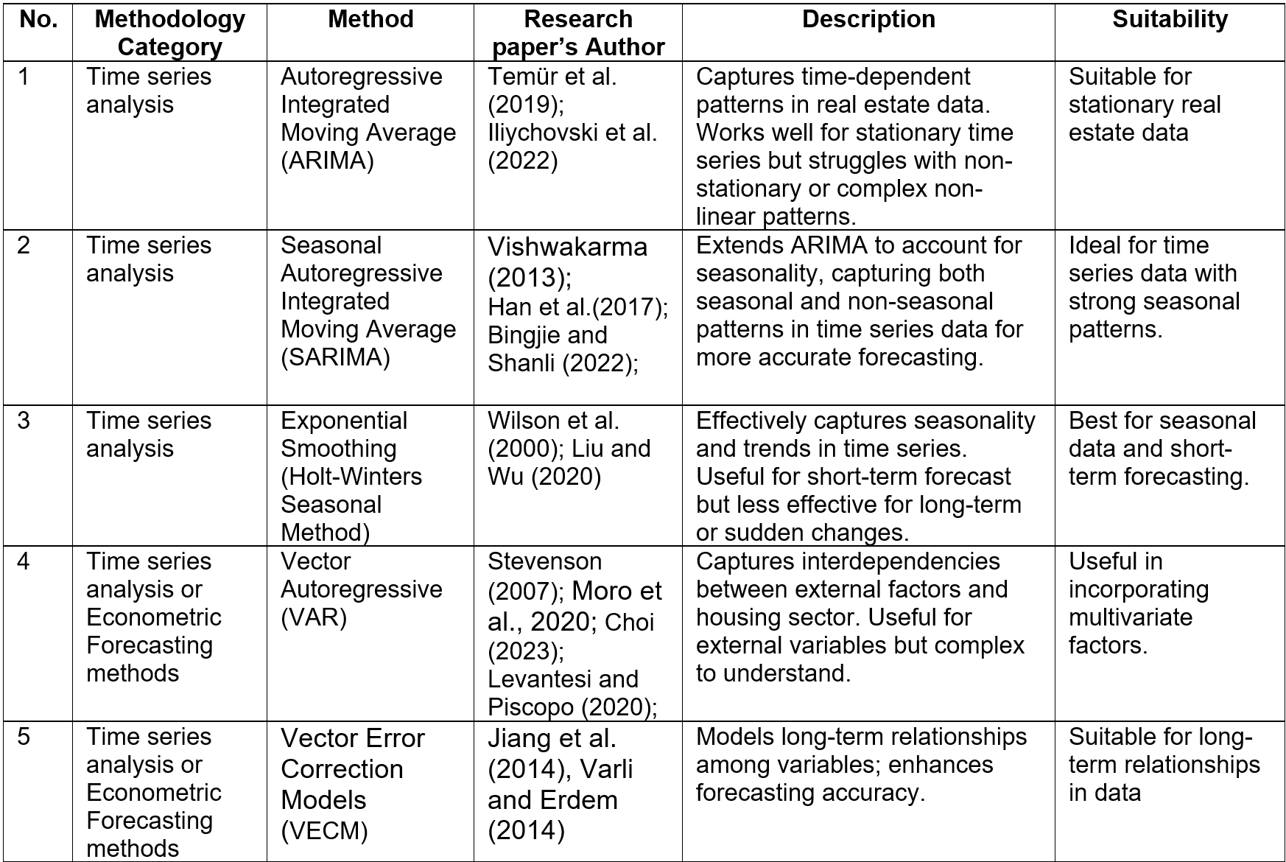
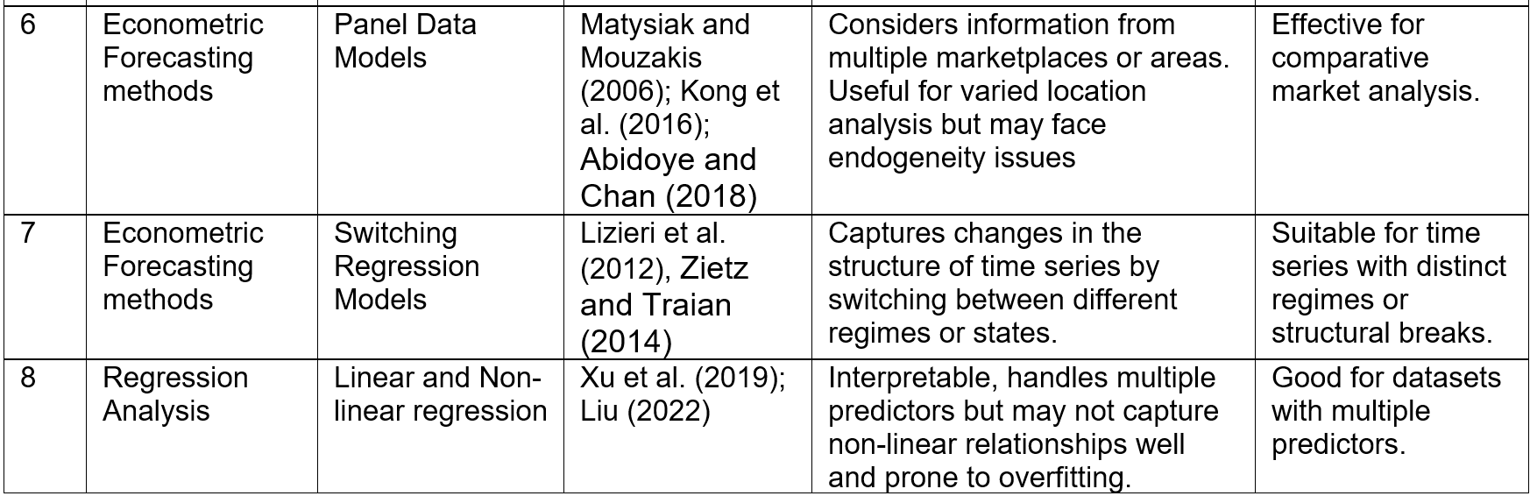
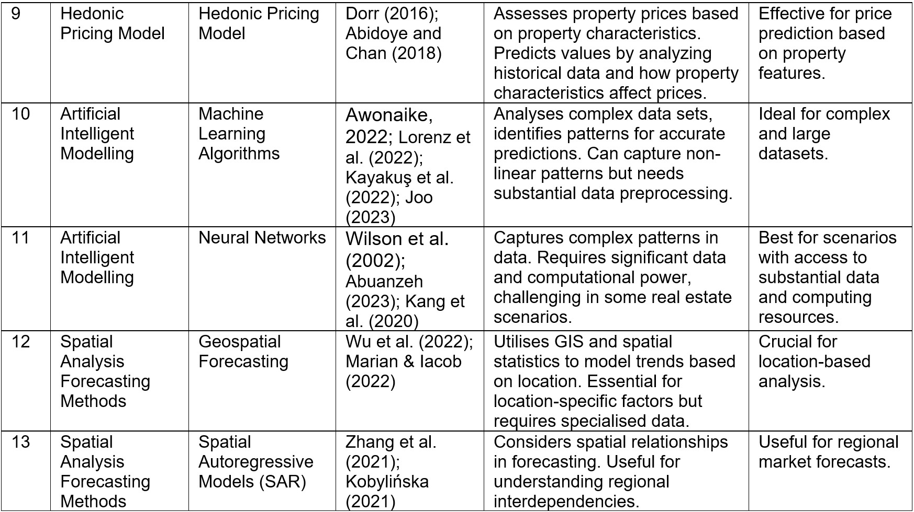

Table-1:Comparative-overview-of-current-residential-real-estate-forecasting-methodologies

Although no definitive conclusions have been reached, numerous studies have compared models to identify the most accurate for predicting housing-sales. Among other univariate forecasting models, SARIMA-is often favoured for handling trends, seasonality, and random fluctuations. Specifically, by comparing out-of-sample turning point performance among univariate methods, Wilson-et-al. (2000) found exponential smoothing models outperform other models only in stable property markets, while SARIMA-excel at predicting market turning points. Moreover, following the Box-Jenkins methodology, Iliychovski-et-al. (2022) highlighted SARIMA's-effectiveness in capturing dynamic seasonal trends, making it a crucial predictive analytics tool for strategic investment and planning in Bahrain’s housing market. According to Han-et-al. (2017), SARIMA-indicated superior-accuracy in forecasting South Korea's housing market compared to multiple regression and neural networks while being much simpler and less risky. Additionally, Wilson-et-al. (2002) investigated-that using-SARIMA models for developing machine learning techniques for house transaction predictions resulted in more accurate forecasts.

However, not-all-literature-supports-SARIMA model. Zietz-and-Traian (2014) used various univariate models, such as SARIMA, Holt-Winters Seasonal Method and switching-regression, to predict-the 2006-U.S. downturns. Resultly, -most-models-predicted-a housing downturn by mid-2006, but-switching-regression were the most accurate, predicting the downturn as early June 2005. Furthermore, Temür- (2019) also-noted-that ARIMA and SARIMA models-can forecast-Turkey housing market in the short-term, but results vary based on model configuration, leading to inconsistencies in accurate predictions in long-term.

Given these-controversial findings and discussions, recent researchers have proposed that incorporating additional parameters into univariate time series models can enhance their accuracy. Zhang-et-al. (2021) -found that-Spatial-Autoregressive-model, which includes the sales or prices of neighoring areas, outperformed SARIMA model in forecasting housing sales in Toronto city. However, among multivariate models, Vector-Autoregression (VAR) and Vector-Error-Correction-Models- (VECM) are favoured for forecasting housing sales as they captures linear interdependencies between multiple time series data, providing a comprehensive and dynamic analysis-of market-trends (Choi, -2023). While VAR captures interdependencies without considering cointegration, VECM-extends it by incorporating long-term equilibrium relationships when-series are cointegrated (Jiang et al., 2014). By comparing ARIMA/SARIMA, multiple-regression and VAR, Stevenson- (2007) identifed VAR as the best-fitting model for predicting U.S. housing sales with the smallest errors. Besides, Varli and Erdem (2014) showed-that VECM outperformed-SARIMA and VAR in forecasting Bangladesh’s housing market by-incorporating variables with long-term relationships to housing sales.

Nevertheless, Vishwakarma’s- (2013) study contradicts these earlier findings, revealing that ARIMA model's simplicity, ease of use, and robustness-to data limitations made it more efficient in forecasting Germany’s home sales-index than more complex models like VAR and VECM. Additionally, Abidoye-and Chan (2018) also determined that SARIMA outperformed multivariate models like Hedonic-Pricing-Model and Panel-Data-Models for out-of-sample forecasts of Nigeria’s housing transactions. Following Abuanzeh- (2023), although AI techniques like ANN-offer some-improvement in-volatile-markets, traditional time series models have consistently demonstrated superior accuracy and reliability, particularly in stable market.

In general, based on-the-literature, SARIMA-and multivariate time-series-models such as VAR and VECM are-two of the most powerful methodologies in forecasting-housing-sales. Given these findings, this-research aims to illuminate the-empirical comparison between these two promising methods through-a systematic-and comprehensive-analysis.

  - Forecasting-housing-sale with Internet data
Amidst the ongoing debate over methodological choices, big data analytics and internet’s widespread availability have become-increasingly crucial for forecasters, significantly enhancing predictive-capabilities (Hohenstatt-and-Kaesbauer, -2014). In numerous settings, internet user-behaviour often reflects collective interests and intentions, suggesting that current online activities correlate with-future actions. Prospective-homebuyers or investors leave digital footprints-during their decision-making-process, searching for locations, real estate types, -prices, and financing options, indicating-their buying-preferences (Yang et al., 2015).

At the start-of-2024, there were 66.33 million UK’s internet users, with a high internet penetration of 97.8% (Figure-1) (Statista, -2024). This widespread usage-allows researchers to study housing participants’ behaviours-using internet data sources. These data can manifest in structured-forms, such as search interest and web traffic statistics, or in unstructured forms, such as-customer reviews and social media posts (Huarng-et al.,-2020). In housing sales forecasting, a-significant shift towards using internet data to predict demand is evident, with Grybauskas-et-al. (2021) noting a fivefold-increase in studies-employing this methodology from 2012 to-2020.

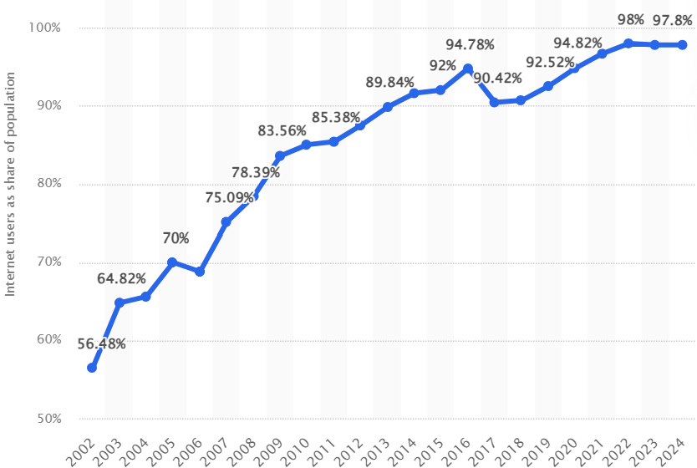
Figure-1:-Share-of-individuals-using-the-internet-in-the-United-Kingdom (UK)-from-2002-to 2024 (Statista,-2024)

Leveraging internet-data-can benefit the housing market-forecasting. Particularly, Wu and Brynjolfsson (2015) emphasized-internet data-provides timely input, unlike traditional economic and business forecasts have relied on-significantly delayed data-published by government-agencies, annual reports, and financial-statements. Therefore, the internet’s prompt information serves as an-early market sentiment indicator, enabling stakeholders to quickly adapt their strategies to housing-market trends (Steegmans, -2021). Similarly, Mitra et al. (2017) highlighted the-advantages-of using-internet data-for nowcasting, enabling-real-time short-term forecasts, and -stressed the-importance of timely data for decision-makers, noting that-delays in traditional-data cycles have historically hindered-accurate responses to current conditions. Consequently, integrating-internet-data is essential-for the housing sector's success, especially with-current increasing-market volatility.

According to Taşcılar-and-Arslanlı (2022), housing-researchers-prefer search interest data as their primary internet data source. As a relative value, search interest is categorised as structured data, comprising-numerical variables that reflect the level of interest in specific search terms over-time, as measured by the number of searches (Choi-and-Varian, -2012). Unlike-unstructured data like-social media-posts, search-interest is simpler-and requires less data processing, making-it less biassed when used as input variables (Dietzel et al., 2014). Furthermore, Humphery (2010) indicated that-using search interest data significantly enhances-forecast-accuracy by-capturing potential housing-buyers’-and investors’ attention, supporting-decision-makers for-faster adaptation-to-market-shifts.

As the-dominant-search engine, Google -launched-publicly-accessible-search data via Google Trends-in 2009, evolving from ‘Google Insights for Search’ (Steegmans, 2021). Unlike other-sentiment-datasets, Google-Trends data is-available just two-days after collection, so the time delay-can-be neglected (Bulczak, 2021). Belej- (2022) highlighted that Google Trends' extensive data coverage, real-time-insights, and user-friendly interface, making it ideal for predicting-housing sales based on community interest in-specific topics. Moreover, by examining Taipei-housing-market, Chang-and-Yin (2021) investigated-that Google Trends data effectively mirrors real-word activities with predictions based on search intensities being unbiased, efficient and highly accurate. Additionally, Lee et al. (2019) augmented ARIMA models with Google Trends data to predict short-term Hong Kong’s housing sales. As a result, the augmented model outperformed traditional univariate time series models, demonstrating search interest's practical ability in forecasting housing demand. The authors also stressed the importance of keyword selection, which significant affects forecasting performance.

According to Vosen and Schmidt (2011), there are several methods for retrieving search terms for studies, including researchers' experiences, academic works, and Google Trends’ search term suggestions. Several scholars, such as Jun et al. (2018) and Bełej (2022), have employed Google Trends categories and subcategories related to housing market as they allow for monitoring not only a single search query but also multiple queries performed before and after the initial search. Conversely, some studies use location and region names in search phrases along with related housing sales keywords like ‘house for sale’ and ‘mortgage’ to provide detailed insights into specific areas (Dietzel, 2016; Huarng et al., 2020).

Numerous studies have adopted search data in different ways. Whereas some authors such as Bangwayo-Skeete and Skeete (2015); Rizun and Baj-Rogowska (2021) used raw Google Trends data, other scholars have combined multiple search terms to enhance predictions. Particularly, Humphrey (2010) and Belej (2023) created a composite index by aggregating search terms data using a shift-and-sum method, which integrated multiple search interest based on their most correlated lag, helping in acheiving 80-85% accuracy in forecasting U.S. home sales. Besides, researchers have recently studied advanced composite index construction methods, such as Principal Component Analysis (PCA) (Gupta and Moodley, 2024). Despite these advances, the best technique is still inconclusive and depends on the specific application. Kurita (2020) endorsed a simpler aggregation method for its clarity and ease of explanation to end-users, while PCA provides statistical advantages that help capture a variety of dynamics but may reduce interpretability. These methods will be chosen in Chapter 3 Methodology to suit UK housing market.

  - Geographical scales in housing sales forecasting
In recent years, various forecasting techniques have been employed to predict housing sales at different geographical scales, with varying levels of complexity and accuracy. Each geographical scale provides unique insights, with national forecasts offering a broad overview, while regional, sub-regional or local analyses provide detailed insights into specific areas, making them valuable for developers, investors, and policymakers (Andrew, 2012). The smaller scales allow for more precise forecasting but require more granular data and sophisticated modeling techniques. Table 2 presents a comparison of geographical scales of existing research for forecasting housing sales.

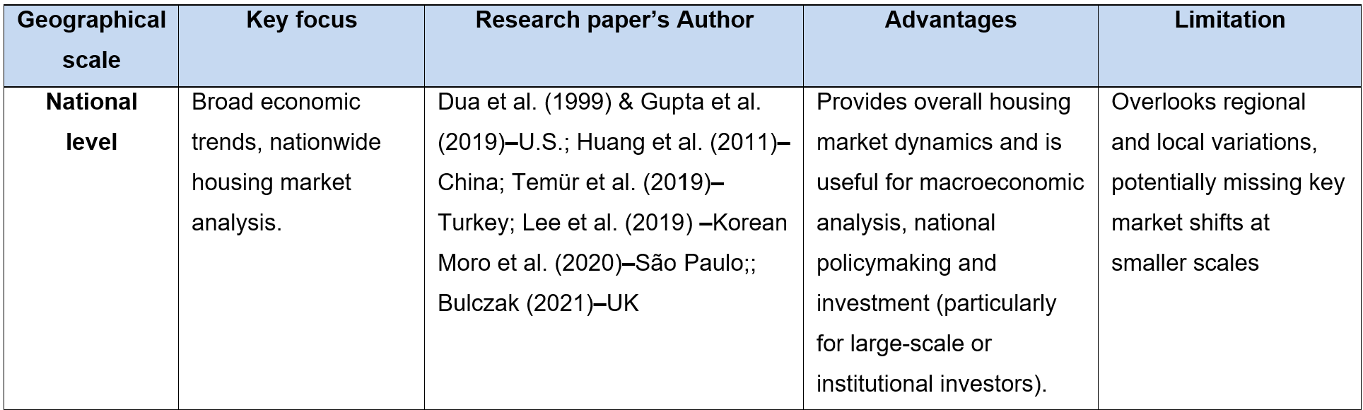
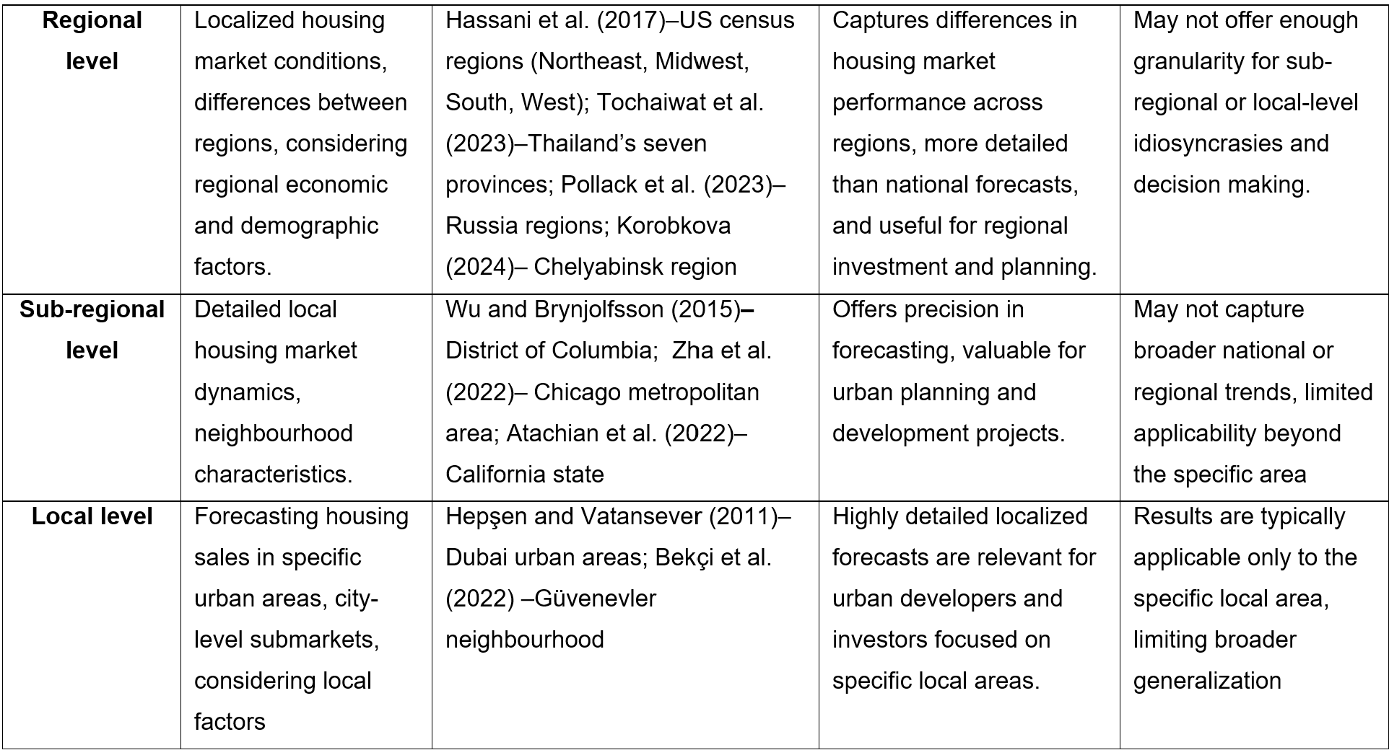
Table-2: -Comparison-of-Geographical-Scales-of-Forecasting-for-Housing-Sales

Beyond the research papers listed in Table 2, some studies have compared various geographical levels in housing sales forecasting. For instance, Paris (2008) and Lee and Park (2022) highlighted that the housing market is inherently localized and forecasting at regional or lower geographical level captures the unique dynamics of specific areas and enhance predictive accuracy, particularly when local market conditions vary significantly from the broader trends. This suggests that focusing on smaller geographical scales allows for a more detailed and accurate understanding of housing market behaviours, which is crucial for making informed decisions in the housing sector.

One approach that has gained attention is hierarchical forecasting, which combines or disaggregates forecasts across different levels of geography allowing for the integration of data from multiple geographic levels, thereby improving the accuracy of forecasts at finer scales (Pennings and Dalen, 2017). Hyndman et al. (2011) explored this method using top-down approaches, where national forecasts are broken down into regional predictions, while Athanasopoulos et al. (2024) proposed bottom-up approaches, where regional forecasts are aggregated to create national-level predictions.

Although hierarchical methods provide a robust framework for multi-level forecasting and have been widely applied in supply chain management, the existing literature on housing sales forecasting reveals that the application of these methods remains limited and underexplored. Most studies on housing sales forecasting focus on single-level models that target either national, regional, or local markets (as shown in Table 2), without explicitly integrating these levels through hierarchical methods. Nevertheless, there was Ong and Chew (1994)’s study that used the Analytical Hierarchy Process (AHP) to forecast sales in the Singapore housing market, highlighting that hierarchical analysis integrates spatial dependencies and ensures consistency across scales, leading to greater accuracy. However, this forecasting study relied solely on expert judgment supported by AHP rather than on quantitative modelling. This gap indicates a significant opportunity to enhance housing sales forecasts by applying hierarchical techniques to quantitative models, which could provide more comprehensive, accurate, and reliable predictions. Exploring this area could yield valuable insights into how broader market trends influence local dynamics and vice versa, thereby improving the utility of forecasts for various housing market stakeholders.

  - Research gaps and paper contribution
Housing sales forecasting has gained significant scholarly interest due to big data analytics and the evolving housing sector, creating opportunities for innovative techniques for market adaptation. This paper contributes to the literature by addressing three research questions.

RQ1: Does Google Trends' search interest data assist in forecasting housing sales in the UK and its regions?

Accurately forecasting housing demand is vital for the UK economy, especially given the increased market volatility caused by Brexit and the COVID-19 pandemic. However, there is limited comprehensive literature on housing sales in the UK and its regions, and existing forecasts often lack precision due to the absence of real-time predictive data. Hence, this study aims to enhance forecasting models by incorporating timely variable, Google Trends search interest data, and assessing its effectiveness in predicting housing sales across the UK and its four regions. The objective is to provide policymakers and investors with deeper insights into housing market trends, enabling more accurate and timely predictions.

RQ2: How effective are univariate and multivariate time series models in predicting housing sales?

Traditional univariate time series models, especially SARIMA, have been recognized to accurately predict housing market trends in extensive literature. However, recent studies suggest that VAR and VECM models can enhance forecasting performance by incorporating external variables, such as search interest. Despite these advances, most literature has concentrated mainly on theoretical or empirical dimensions, frequently overlooking real-world application and its importance to industry stakeholders. Therefore, this study aims to contribute to the existing literature by comparing the performance of a univariate model—the SARIMA model—and multivariate models to draw practical implications for the housing sector.

RQ3: Can hierarchical-forecasting-approach-enhance-the accuracy of UK housing sales predictions?

As mentioned above, there-is-still a research gap in developing hierarchical techniques to quantitative models that account for different regional-housing buying behaviour. Thus, this study will employ hierarchical-forecasting by both a top-down approach, disaggregating national UK’s housing sales forecasts-into four regional ones, and-a-bottom-up approach, combining-regional-forecasts for-UK national predictions. This approach is especially-relevant to the UK, where the four regional-housing-markets differ significantly, as detailed in Section 3.1.3.

In summary, this-research-contributes-to the current housing-sales forecasting literature by implementing-a practical-methodology that emphasises simplicity-and effectiveness. Firstly, it explores the use of-Google Trends-search-interest data to predict housing sales of UK-and its regions. Secondly, the study compares univariate and-multivariate time series models to understand their real-world strengths and weaknesses. Finally, it employs hierarchical forecasting to generate more detailed-predictions across the UK's four-regions by using region-specific-search-interest data, which-is then-combined to-forecast at the national level. By addressing these-objectives, this study-aims -to advance current-housing sales forecasting insights and-provide-practical-implications for-market-decision-makers.

Chapter 3: Methodology

This chapter is structured into-four sections, covering key concepts-and methodologies. The first describes the-input data, its origins, and limitations, along with an exploratory data analysis to guide-methodology selection. The second-develops the Search Interest Index (SII), a key input for models. The-third section outlines the time series forecasting methodologies and the final section discusses the evaluation method and metrics for assessing predictive accuracy in housing sales.

The methodology is-summarised as-follows:

- Construct SII from search terms in Section-3.2 and integrate Google Trends’ search subcategories and SII separately into multivariate models to-analyse their predictive performance. This comparison will-assess whether two Google Trends data types support in forecasting housing sales—helping to answer RQ1.

- Develop univariate and-multivariate time series models, SARIMA and VECM, in Section 3.3.2-and-3.3.4 to compare their-forecasting performance—helping to answer RQ2.

- Establish ‘Aggregate’ and ‘Hierarchical’-models in Section 3.3.5 to assess their predictive accuracy—helping to answer RQ3.

3.1 Data source and input
Time series forecasting-typically-requires minimal input, often relying solely on the time series data for univariate forecasting. Nevertherless, data quality, timeframe, and frequency are critical. Since time series forecasting depends on historical data to identify patterns, a sufficiently long-dataset is essential (Araghinejad, 2014). Moreover, the data frequency is important as-it-determines the number of observations—higher frequencies provide more data points and-vice versa. It is vital to match the data frequency with its temporal characteristics, such as using monthly data for-monthly seasonality case. Additionally, the practicality of forecast frequencies should be considered as business-practitioners often adhere to specific planning cycles.

3.1.1. Housing-sales-data
Based on Figure 2-of the UK home purchase timeline, HMRC-and the Land Registry are key sources for housing transaction volume data. HMRC, the UK’s tax authority, manages-the tax collection of-national-insurance-system and other regulatory regimes, including Stamp Duty Land Tax (SDLT) on property sales and land-transactions. The HM-Land-Registry, the UK government department, is responsible-for maintaining-the UK’s land-and-property ownership records, ensuring-transaction-integrity-and-secure ownership-transfers.
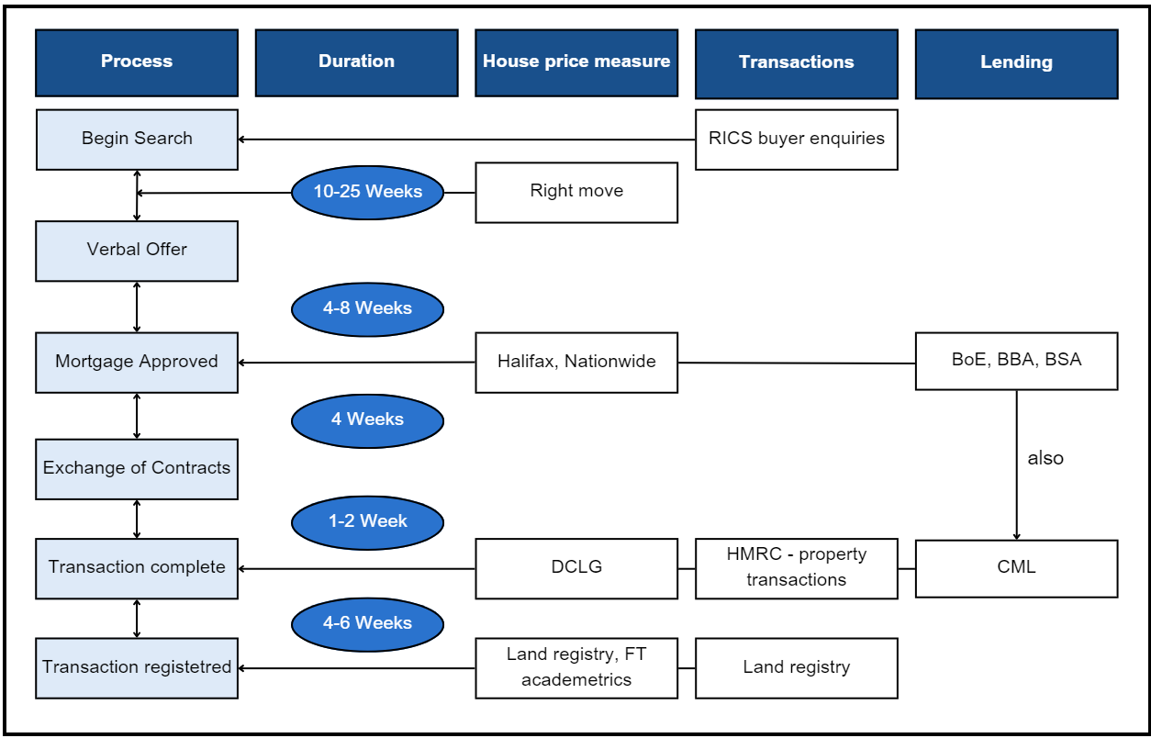
Figure-2: Home-Purchase-Timeline-in-the-U.K. (Hohenstatt-and Kaesbauer,-2014)

HMRC provides-property-transaction-data for tax purposes, focussing on-SDLT transactions, covering completed transactions when-sale finalization and SDLT return filing (GOV.UK, 2024). Conversely, HM-Land-Registry records all registered-UK property sales, which occurs once the legal title is transferred-and duly recorded (Telfer, 2018). According to-Table 3, Land Registry data is preferred-for forecasting-UK housing sales due to its comprehensive coverage, frequent-updates, and high reliability, offering a comprehensive-view and robust basis for-analysis-and prediction.
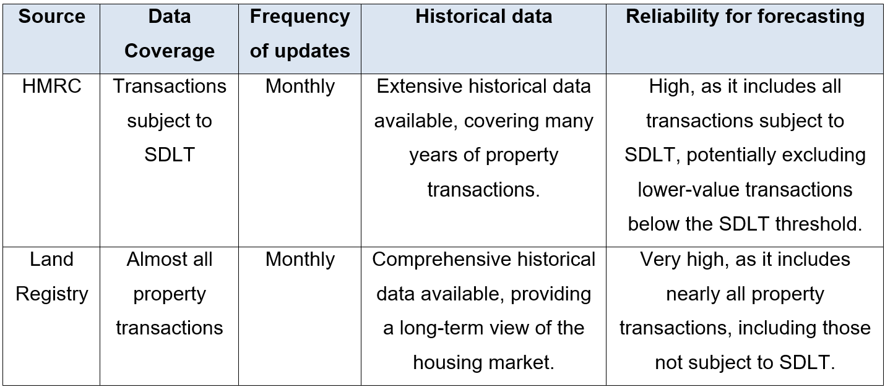
Table 3: The comparision between two sources of housing sales data (GOV.UK, 2024).
The Land Registry-offers sales volume data for-all housing-property types across the UK and by region, including-England, Northern-Ireland, Scotland, and Wales. This dataset's monthly breakdown is ideal for-seasonality-and-business planning. Markedly, this-dataset is available from-January-2005-to-March 2024.

3.1.2. Google Trends search interest
The section 2.2 underscores the-potential benefits-of incorporating an external variable to enhance model accuracy, identifying search interest as the focus for this study. Google Trends, a well-known source, provide a search interest -across different geographic locations and time periods, since-January 2004. Instead of absolute query numbers, this query index is measured by query-share, calculated as the volume of searches for a term in a specific geographic location divided-by the total number of queries-in that region at a particular time. Consequently, the-index measures the popularity of a term or phrase from 0-to-100, with 100 indicating the-highest-search-interest-and popularity for the selected-time and place (Google, 2024). Typically, Google calculates-search-interest daily, weekly, -or monthly and can be broken down by-geographic levels, from-global-to-city-specific.

To decide between utilizing-search terms or search categories/subcategories from Google Trends, two-aspects are considered: noise versus data precision and reproducibility. Accordingly, Preis-et-al.-(2013) -and Wu-and-Brynjolfsson- (2015) argue that subcategories, aggregating related search terms, offer more stable and reliable data by providing a broader trend overview. Google's proprietary natural language-processing-groups related search terms into categories by analyzing not only individual queries but also those made before and after (McEntire-et al., 2016). For example, "home appraisal" followed by "property listings" would fall under "Real Property Listings," while "home appraisal" and "interior design ideas" might be categorized under "Home-&-Garden". While search categories/subcategories are less affected by-search term fluctuations, they may miss subtleties-and be too broad for precise analysis. Hence, Mitra et al. (2017) suggest that, despite higher noise levels, individual search terms offer detailed, flexible-data for targeted analysis. Consequently, to provide a comprehensive comparison, this-study uses both types of Google-Trends data for forecasting housing sales. Following Askitas and Zimmermann (2009), popular search terms are combined into a-unified index, while the subcategories offered by Google Trends are leveraged, analogous to-Hohenstatt et al. (2011) and Choi and-Varian (2012).

The selection of search terms is crucial for forecasting accuracy. Bulczak's (2021) UK housing market study shows that search terms are chosen using logical keywords that have been tested for housing sales forecasting. He noted that "house for sale" and "mortgage" positively correlate with housing sales and aid in predicting market fluctuations, especially during the 2007-2008 global financial crisis. The term "house for sale" directly relates to housing sales, whereas "mortgage" is the primary method of financing home purchases, indicating homebuying intentions. Additionally, as the most searched keyword in the UK Property category, "Rightmove"—one of the largest and most popular property websites—was also chosen (Figure-3). Particularly, Rightmove accounts for 80% of UK online property searches, making it essential for buyers, sellers, and real estate professionals to understand consumer behaviour and UK housing market trends (Paton, -2019).

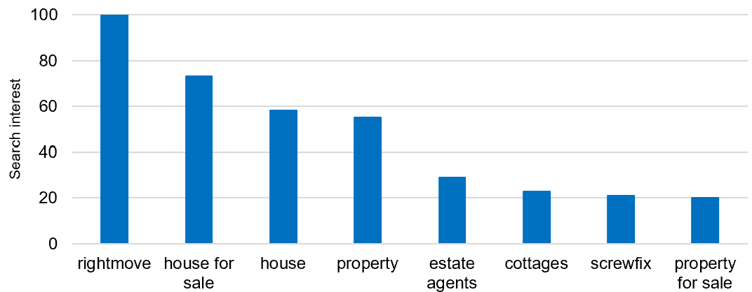
Figure-3: Top-10-search-terms/-queries-in-Property-category- (Google-Trends, -2024)

For subcategories, Hohenstatt and Kaesbauer (2014) identified "Real Estate Agencies" (REA), "Rental Property Listings" (RPL), and "Home Financing" (HF) as proxies for renting, buying, and financing-decisions to model-sentiment in near-future housing transaction. REA and HF directly involve buying and selling real estate and positively affect housing sales. Conversly, RPL offer an alternative-to buying and reflects market shifts, where high rental listings may indicate a slower housing sales market as more properties-are available for rent for lack of sales. Collectively, these subcategories-cover various but interconnected housing market aspects, providing comprehensive market coverage. Thus, monitoring these searches allows forecasters to anticipate housing sales changes, making these subcategories crucial for accurate market forecasting.

The Google Trends data summarized-in-Table-4 is filtered by location at-both the national and regional level. Web search-traffic was chosen for its direct correlation with consumer behaviour and-housing market activity, offering high-quality, frequent data that captures the most-actionable market indicators, making it the best data type for accurate and timely housing sector forecasts. Focusing-on the-UK housing market, only-English search-terms were used to ensure consistency and avoid biases from translation.

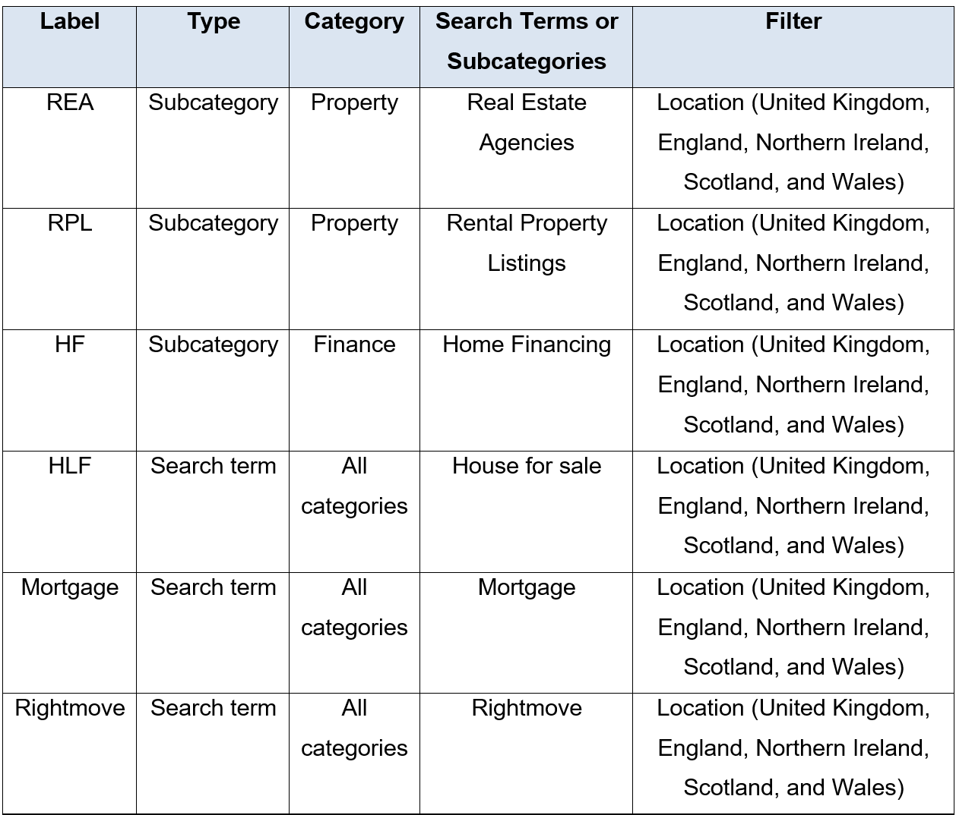
Table-4: The-Google-Trend-data

In-time-series-models, aligning the time-frames of all variables is crucial for accurate predictions, as misalignment can distort relationships and compromise forecast precision. Therefore, a total of 15-search subcategories and 15 search-terms for the-UK and its four regions, covering-January-2005-to-March-2024, were downloaded from Google Trends website and-further-processed-in-R.

3.1.3. -Exploratory-Data-Analysis
The exploratory data analysis provides initial insights into the temporal structure of UK and regional housing sales, guiding the selection of methodology. Figure 4 highlights the UK housing sales time series, with key periods marked by different colours: Pre-Brexit, Brexit, and COVID-19. The Pre-Brexit period shows significant fluctuations, peaking in 2006-2007 before a sharp decline and volatile recovery. The Brexit period, starting in early 2017, shows more stable but lower sales due to market uncertainty. The COVID-19 period features a sharp drop in sales due to lockdowns, followed by a spike from pent-up demand and government incentives, then a decline influenced by rising inflation and interest rates (Nguyen, 2023). Overally, the Brexit era has the most stability and clear monthly seasonality, making it ideal for time series modelling to optimise predictive accuracy.

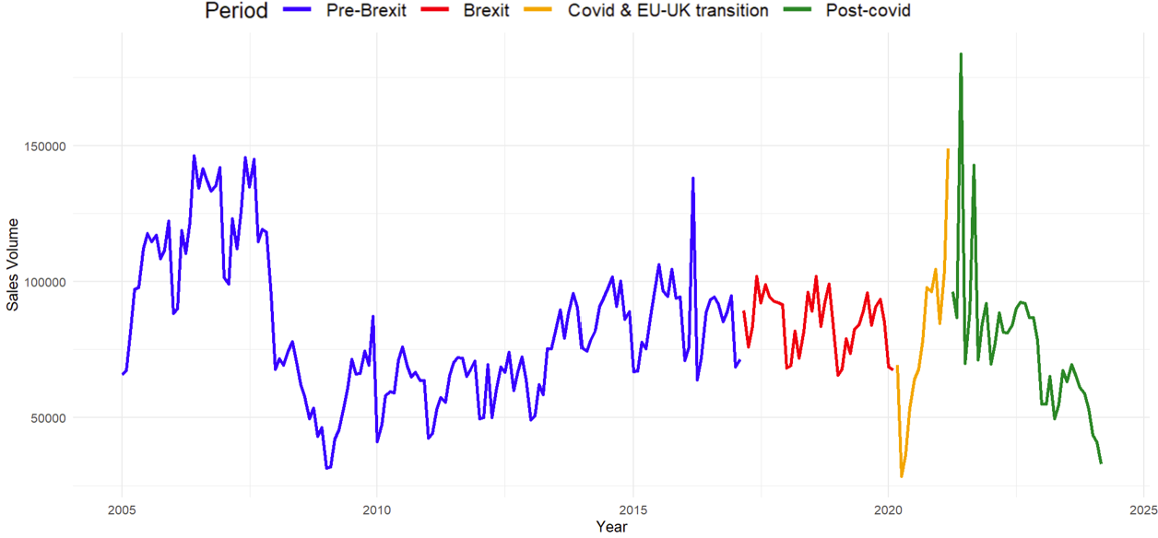
Figure-4: -UK-housing-sales-volume-over-time-for-different-periods-from-2005-to-2024

The strong seasonal pattern of UK housing sales is clearly shown in Figure 5, while the trend fluctuations are less apparent. Significantly, the housing demand tends to increase and peak during summer months (June to August) and decrease to hit its lowest during winter (December to February) (Figure 6).

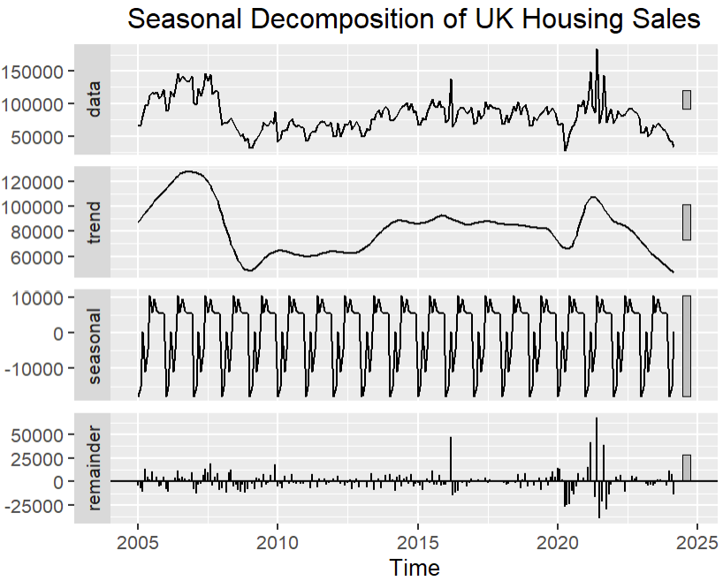
Figure-5: -Seasonal-Decomposition-of-UK-Housing-Sales

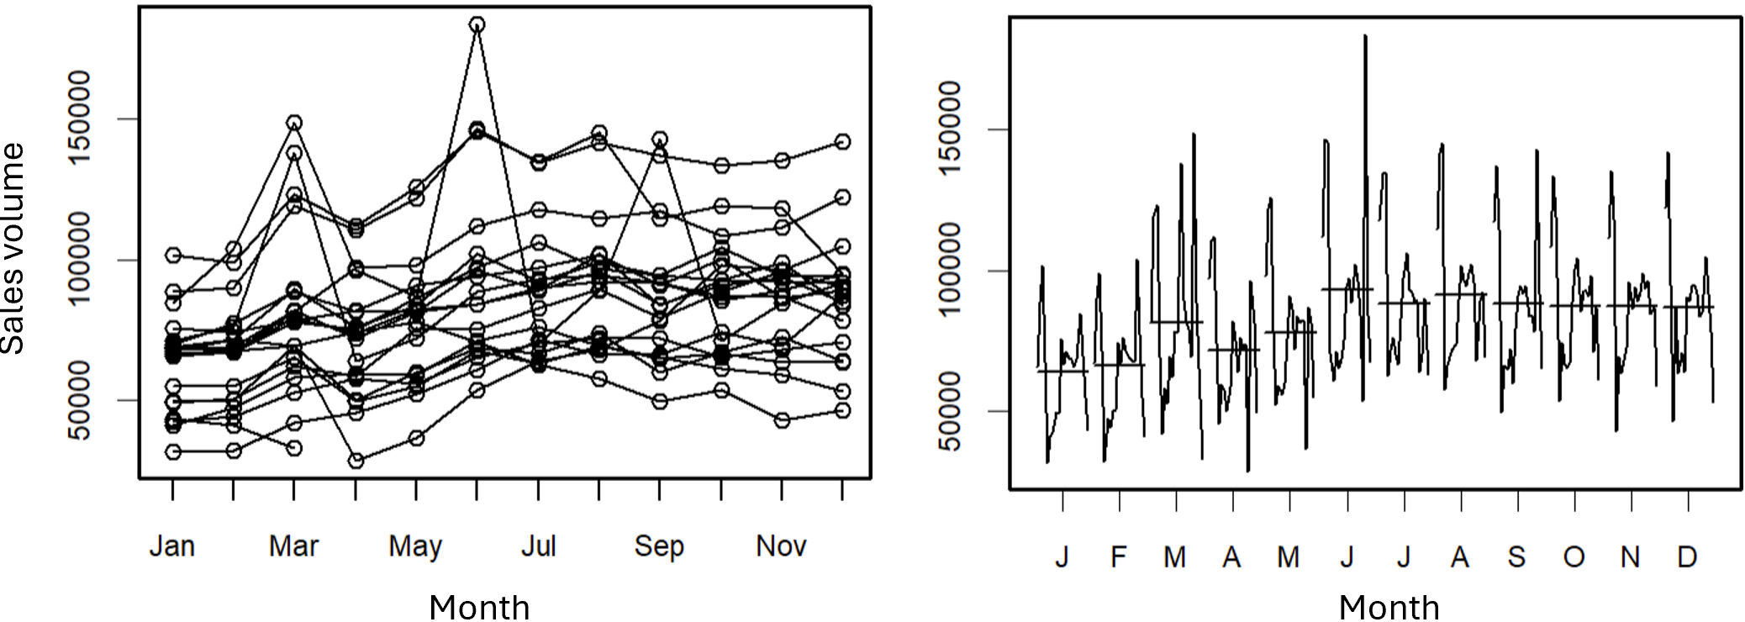

Figure-6: -Monthly-plot-for-UK-Housing-Sales

The regional housing sales charts-closely mirror the-overall UK trend (Figure 7). England leads with the highest volumes, peaking around 160,000, and closely aligns with the national trend, making it a strong representative of the UK market. Northern Ireland has the lowest sales, showing a steep decline post-2007, followed by a slow recovery and a pandemic dip. Scotland and Wales exhibit similar patterns, with declines after 2007, fluctuations around 2016 and 2020, and recent drops. All regions show clear seasonality, influenced by events like the financial crisis, Brexit, and Covid-19 pandemic.

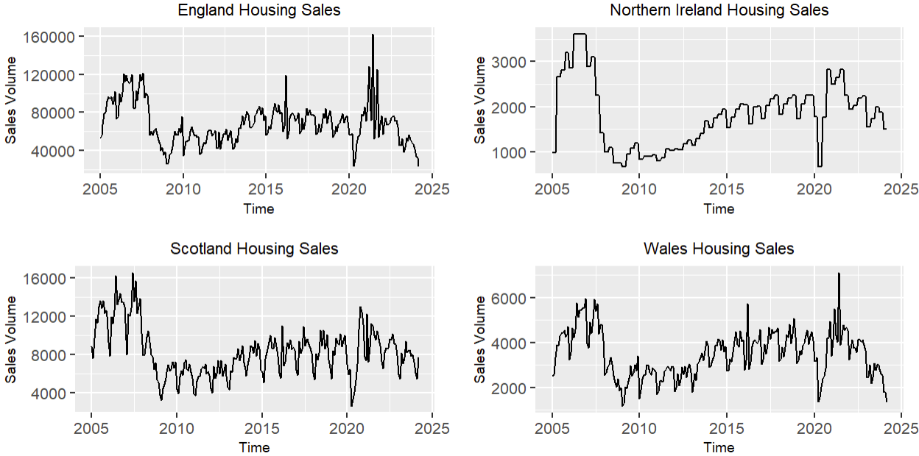
Figure-7:-The-housing-sales-volume-in-four-UK-regions

3.2. Search Interest Index (SII)
This section explores the development of the composite index, which reduces data dimensionality and streamlines model inputs, enhancing predictive capabilities. The process is outlined in Figure 8 and detailed in Sections 3.2.1 and 3.2.2.

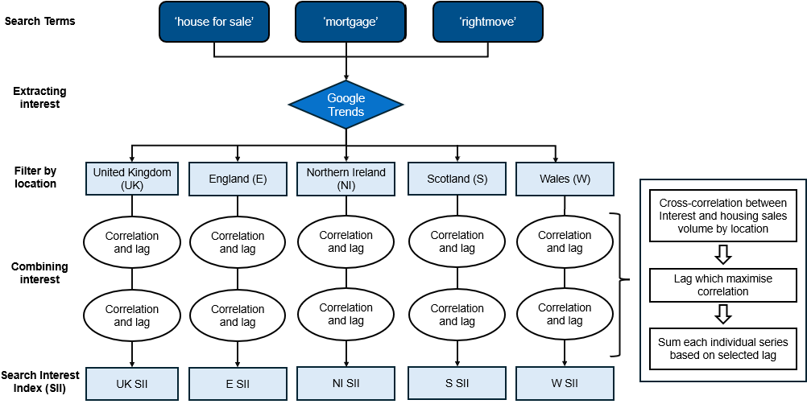
Figure-8:-The-construction-process-of-Search-Interest-Index (SII)

3.2.1. Selection of data inputs for Search Interest Index

Since subcategories aggregate search activity across related terms, creating another composite index from the three mentioned subcategories is redundant (explained-more-in Appendix-1). Therefore, this study focuses on using search terms to create composite indexes, comprising 15 distinct search interest time series from 5 categories (Figure 9). The UK overall and England show similar patterns with high, consistent interest, particularly in "house for sale" and "Rightmove" reflecting a stable and active housing market. Northern Ireland exhibits greater volatility, especially in "house for sale" searches, indicating fluctuating market activity. Notably, "Rightmove" searches in Wales have declined since 2015, suggesting decreased reliance on this platform for checking housing sales. Scotland shows a stable pattern similar to England but with less variation, indicating a consistently active market. Wales has the lowest overall search interest, with initial volatility stabilizing at lower levels, suggesting a smaller or less active market. Overall, the data highlights distinct regional housing market diversity, with England and Scotland showing higher activity, while Northern Ireland and Wales exhibit varying degrees of market engagement and stability.

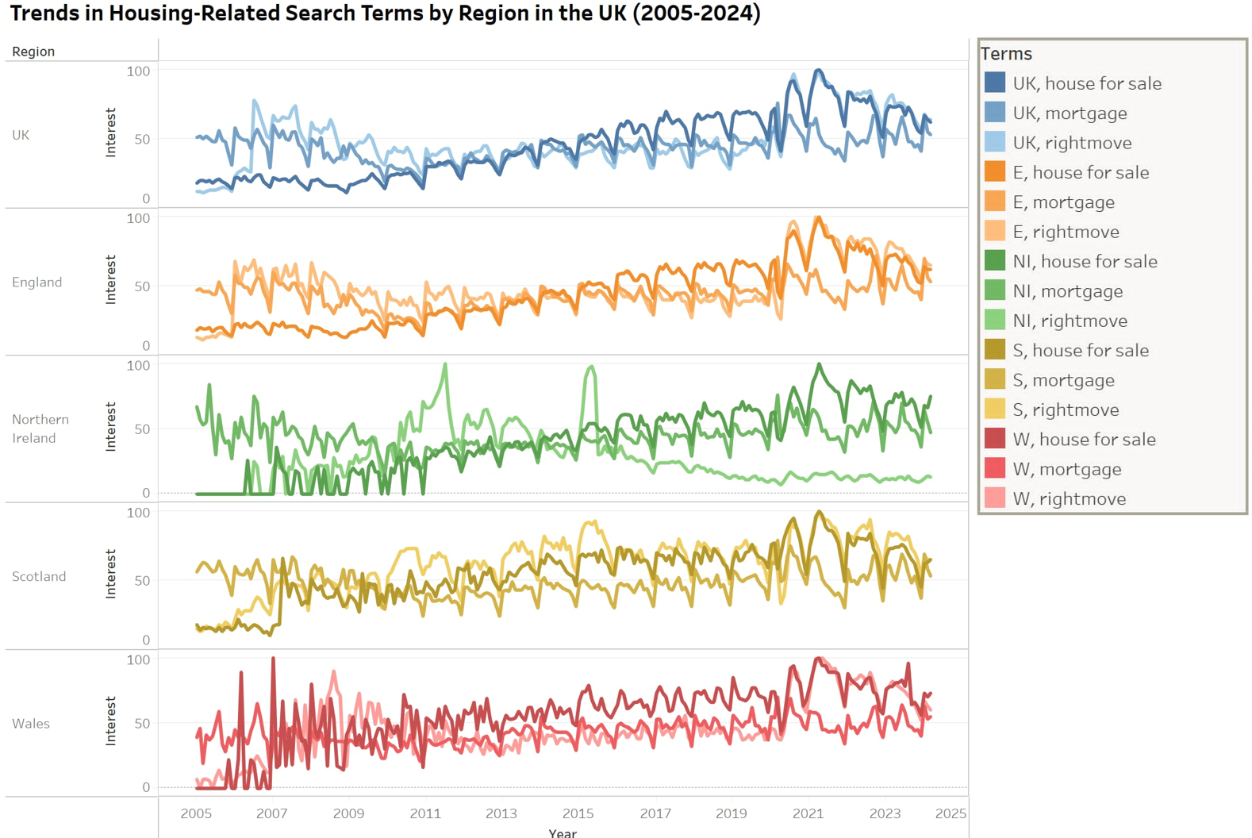
Figure-9:-The-search-interest-by-search-terms-and-region-in-the-United-Kingdom

3.2.2. Search data composite

To simplify data dimensionality, the shift-and-sum method was chosen for its straightforward approach. According to Jiang et al. (2023), search queries related to housing sales have lags before leading to purchases, ranging from weeks to over a year, typically between 0 to 15 months. Specifically, first-time homebuyers generally have longer lags due to the need for research and financing, while urgent buyers have shorter lags. By identifying the lag that maximizes the Pearson correlation between a particular search interest and actual sales, each search interest is ‘shifted’ by the corresponding lag. This enables more accurate alignment of online search behaviour with housing transactions’ timing. Table 5 shows optimal lags for each search term and region, ranging from 0 to 20 months, with correlations from 0.4 to 0.8, indicating moderate to strong relationships. Notably, Northern Ireland's 20-month lag may be due to Brexit-related uncertainties, including geopolitical issues and political complexities, which delayed potential buyers’ purchasing decisions (Daniels and Kuo, 2021).

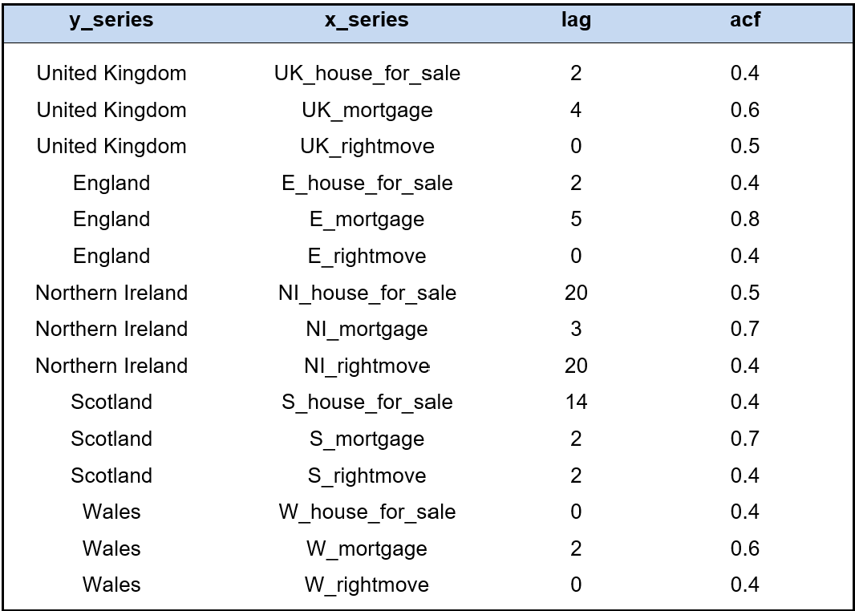
Table-5:-The-number-of-lags-that-maximize-Pearson-correlation-and-its-associated-value

Subsequently, the search terms of UK and each region were combined to create a composite measure called the Search Interest Index (SII) for five locations including UK, England (E), Northern Ireland (NI), Scotland (S) and Wales (W). While the shift-and-sum method lacks the statistical rigor of techniques like PCA, it is effective for housing sales, enabling straightforward aggregation of search terms and revealing trends and correlations that might otherwise be obscured while ensuring data alignment (Shao et al., 2019). Figure 10 shows the aggregated SII for each region, generally mirroring housing sales patterns, especially in seasonality. Notably, Northern Ireland's SII lags behind other regions, indicating a delayed connection between search terms and market activity, consistent with earlier analyses (explained-more-in-Appendix-2).
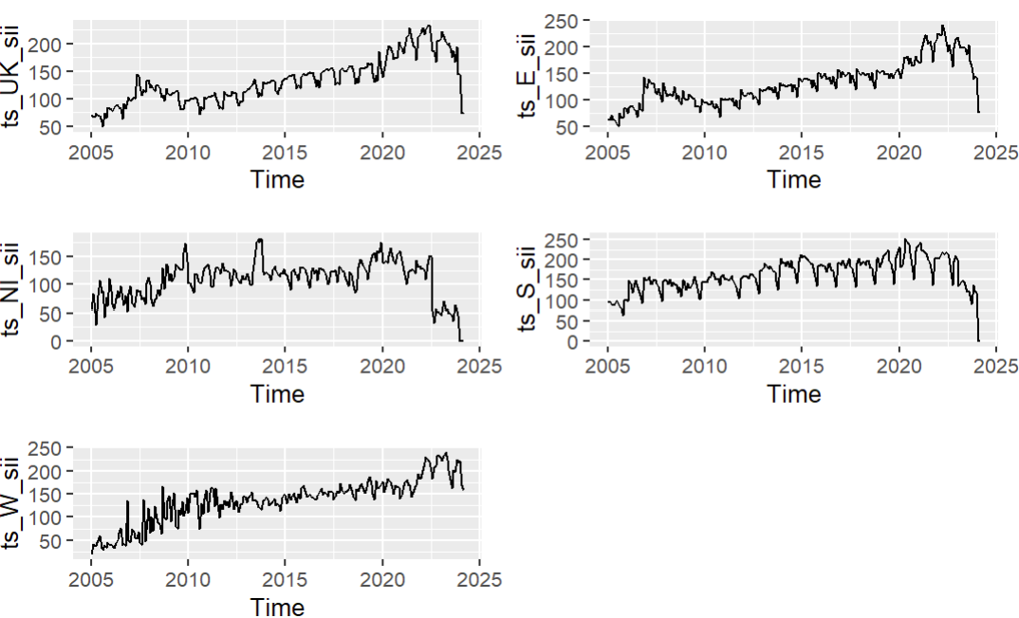
Figure-10: Search-Term-Interest-(SII)-for-UK-and-its-regions

3.3. Time Series Forecasting models
This four-part section introduces forecasting model concepts and methods. The first part covers essential statistical tests for model requirements, focusing on stationarity and cointegration. The second part explains the SARIMA methodology, the selected univariate model. The final two parts describe two interrelated multivariate models.

3.3.1. Time series statistical tests
Kitagawa (2010) stressed that analysing time series characteristics is a crucial initial step in modelling and mmodellers must deeply understand these properties to effectively incorporate them into the data generation process.

Stationarity is a key aspect of time series analysis and often a prerequisite for many models. Adhikari and Agrawal (2013) stated that Kwiatkowski-Phillips-Schmidt-Shin (KPSS) and Augmented Dickey-Fuller (ADF) tests are fundamental tools in assessing stationarity due to the distinct nature of their null hypotheses regrading stationary. The ADF test checks for unit roots, indicating non-stationarity, while the KPSS test examines stationarity around a deterministic trend (Sjösten, 2022). Combining both tests provides a comprehensive view of stationarity, essential for accurate forecasting and justification of parameters selection.
Additionally, cointegration is crucial in multivariate time series models. According to Neal (2014), cointegration occurs when a linear combination of two or more non-stationary series produces a stationary series, indicating a long-term equilibrium relationship among variables.
Johansen’s test, as noted by Jalil and Feridun (2011), is a robust method for cointegration analysis of multiple non-stationary time series to determine the presence and number of cointegrating vectors. By employing a vector error correction model, the test identifies the cointegration matrix rank, indicating the number of existing cointegrating relationships.

3.3.2. Seasonal Autoregressive Integrated Moving Avergage (SARIMA)
Considering the characteristics of housing sales, the SARIMA model is selected as the preferred univariate approach due to its effectiveness in capturing trends, seasonal patterns, and random fluctuations (Dubey et al., 2021). As highlighted in Section 3.1.3, UK and regional housing sales exhibit distinct seasonal patterns and significant yearly variations.

The SARIMA model extends ARIMA to handle time series data with seasonal patterns by incorporating both non-seasonal (AR(𝑝), I(𝑑), and MA(𝑞)) and seasonal part (SAR(P), SI(D), SMA(Q) and seasonal period S) (Dabral and Murry, 2017). The integration components I(d) and SI(D) address non-seasonal and seasonal trends, respectively, by differencing the data to achieve stationarity. The AR (Autoregressive) component models an observation's relationship with its past values, while the SAR (Seasonal Autoregressive) component applies the same principle to previous seasons, capturing both short-term and seasonal dependencies. Furthermore, the MA (Moving Average) component captures the relationship between an observation and residual errors from previous observations, while the SMA (Seasonal Moving Average) component applies this to errors from prior seasons, accounting for both regular and seasonal variations. Cumulatively, SARIMA process can be succinctly represented as ARIMA(p,d,q)(P,D,Q)_{S}.

Although SARIMA is a powerful univariate model, its effectiveness depends on precise parameter selection. The Box-Jenkins methodology offers an iterative process for determining the best-fitting model, involving four key steps, as illustrated in Figure 11.

- Model Identification: This step involves analysing the data's structure, including seasonality, trends, and autocorrelations, and applying the Guerrero test to determine if variance-stabilizing transformations are needed.

- Model Estimation: After identifying the model structure, the ‘auto.arima’ (Appendix 3.1) function in the ‘forecast’ package automatically selects the best parameters model by minimizing information criteria Akaike Information Criterion (AIC), Corrected Akaike Information Criterion (AICc), and Bayesian Information Criterion (BIC), ensuring an optimal balance between fit and complexity. Additionally, Autocorrelation (ACF) and Partial Autocorrelation (PACF) plots are used to validate the selected model.

- Diagnostic and Adequacy Test: Fit the proposed model(s) and evaluate them using error metrics and residual diagnostics (Section 3.3.6) to ensure they resemble white noise. If patterns or correlations persist in the residuals, refine the model and explore improvements until no further enhancements are possible.

- Forecasting: Once a satisfactory model is obtained, it can be used to forecast future values of the time series, including confidence intervals.

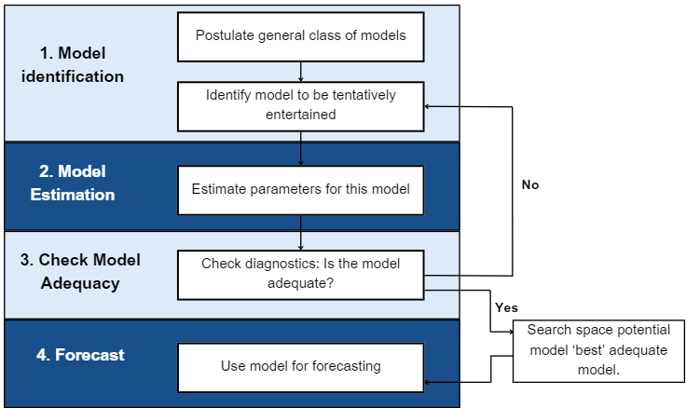
Figure-11: -Box-Jenkins-Methodology

3.3.3. Vector Autogressive (VAR)
The cross-correlation findings in Section 3.2 demonstrate a significant correlation between the SII and UK housing sales volume, suggesting that multivariate models could leverage Google Trend data to improve forecasts. Nielsen and Popiel (2018) highlight VAR as a preferred time series model due to its ability to capture dynamic interdependencies and interaction among multiple variables overtime. Unlike univariate autoregressive models, VAR is a system of equations that regresses each variable on its own and other variables' lagged values (Nakajima, 2011).

However, VAR does have certain limitations. The model requires stationary inputs, a condition that many time series do not naturally satisfy, and struggles to capture long-term relationships between cointegrated variables (Giacomini, 2013). Hence, the VECM appears as an extension of VAR that addresses these issues.

3.3.4. Vector Error Correction Models (VECM)
VECM is a time series model designed to explore long-term relationships and cointegration, indicating stable prolonged equilibrium among non-stationary variables (Jian et al., 2019). Following Zou (2018), VECM is valuable for analysing dynamic interactions and immediate adjustments within integrated variables, making it a widely used in finance and econometrics for predictive modelling. Before fitting a VECM, two key parameters must be determined.

- Lag Order: The lag order in VECM model determines the number of previous time steps used to predict current values, crucial for capturing short-term dynamics. The optimal lag order is identified using the "VARselect()" function in R (Appendix 3.2), which evaluates different orders and selects the most appropriate one based on criteria like AIC and BIC. In this study, AIC is preferred for its balance between accuracy and simplicity, helping to capture data dynamics while minimizing overfitting (Vrieze, 2012).

- Cointegration Rank: The cointegration rank identifies the number of enduring relationships among integrated variables. After selecting the optimal lag, Johansen’s test, as discussed in Section 3.3.1, is performed using the “ca.jo()” function to verify these relationships (Appendix 3.3 ).

After determining the cointegration rank and lag order, the VECM model can be built using the “VECM()” function in R for forecasting (Appendix 3.4). If cointegration between housing sales volume and Google Trend data (SII and search subcategories) is confirmed, VECM will be the ideal modelling approach.

3.3.5. Model framework
To compare univariate and multivariate models, aggregate and hierarchical forecasting and two different types of Google Trends data—search subcategories and SII, 15 distinct models were developed, categorised into 6 groups based on input and model parameters (Figure 12). ‘Aggregate’ models use consolidated UK housing sales data, while "Hierarchical" models focus on regional transactions. By employing a top-down approach, UK and regional models are independently tailored and evaluated for a reliable fit. Moreover, forecasts from each hierarchical model (models 4-7, 8-11, and 12-15) are also evaluated to compare SARIMA and VECM performance, and then combined to produce a collective national forecast following bottom-up approach. This integrated forecast allows for a comparison with the "Aggregate" approach results.

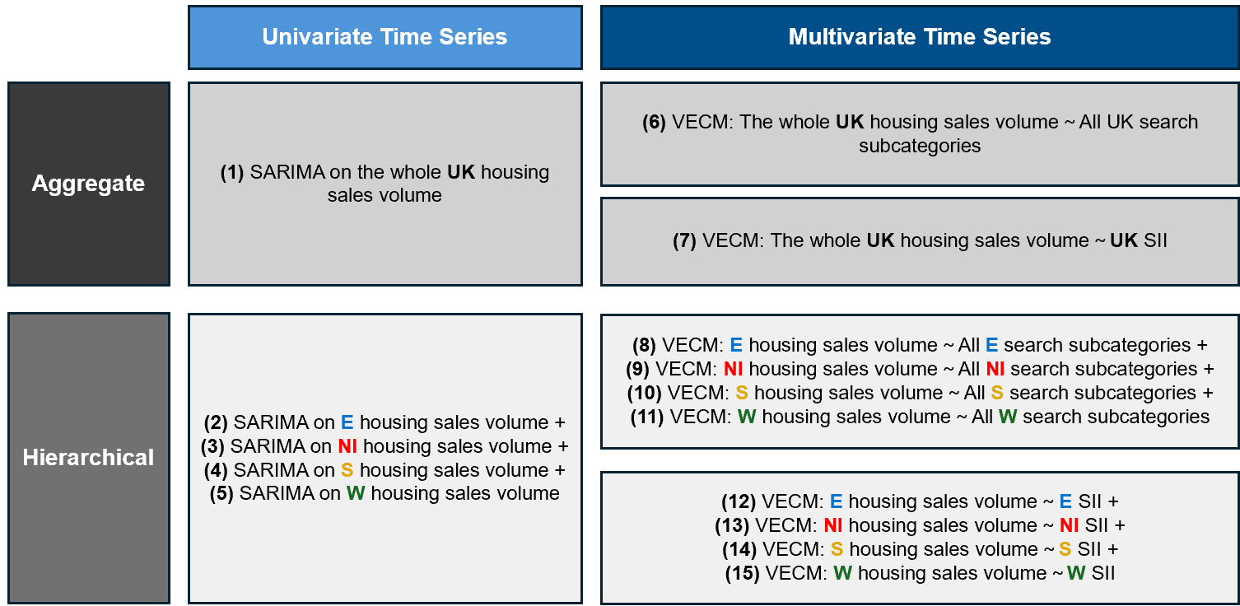
Figure-12: Model-framework
(Notes: -All-search-search-subcategories-including-REA, RPL-and-HF)

3.3.6. Residual diagnostics
Residual diagnostics are essential in both univariate and multivariate time series models to ensure the model is correctly specified by examining the residuals (differences between observed and predicted values). This study includes four key tests for proper diagnostics.

- Normality: Non-normal residuals suggest the model may not fully capture the data structure, indicating a need for transformations or alternative models. Residual normality can be assessed with a histogram or Q-Q plot.

- Autocorrelation: Significant autocorrelation in residuals indicates the model may miss key time-dependent structures, suggesting the need for added complexity. An ACF plot and Ljung-Box test are commonly used to detect this autocorrelation.

- Heteroscedasticity: In a well-specified model, residuals should be homoscedastic, with constant variance over time, ensuring reliable estimates and valid inferences. Thus, Autoregressive Conditional Heteroscedasticity (ARCH) test is employed to detect heteroscedasticity, signalling the need for model adjustments or re-specification.

- Stationarity: Stationary residuals suggest the model has captured all relevant dynamics, leaving only random noise. This is typically assessed using the ADF and KPSS tests.

By conducting these tests, the best model will be selected to ensure reliable predictions and verify that model assumptions are met, while also identifying potential improvements.

3.4. Evaluation method and metrics

3.4.1. Evaluation method
In model validation, data is split into training (in-sample) and testing (out-of-sample) subsets to evaluate model performance on unseen data. This approach prevents overfitting, ensures robustness, and provides a reliable performance estimate for real-world applications like the housing market (Fabozzi et al., 2020).

Accordingly, the out-of-sample forecast for March 2019 to February 2020 was chosen for key reasons. Firstly, this period provides a full year of data, capturing sufficient observations of seasonal peaks and troughs in housing sales and reflecting usual Brexit economic trends. Secondly, March 2019, marked by the ‘Brexit Deal Rejections’ event (Appendix 4), brought significant economic and political uncertainty, specially negatively affecting Northern Ireland due to concerns over the Irish border (Phinnemore, 2022). Furthermore, there is a lack of research on housing sales during this significant Brexit-related event. Therefore, this period was chosen to test the models' adaptability during the Brexit crisis, just before COVID-19 restrictions in March 2020.

3.4.2. Evaluation metrics
To assess predictive time series models, Mean Absolute Error (MAE), Mean Absolute Percentage Error (MAPE), Mean Percentage Error (MPE) and Root Mean Squared Error (RMSE) are key metrics as each offering unique insights into different model performance’s aspects. MAPE calculates the average absolute percentage error, meaning the difference between observed and predicted values, making it scale-independent and easier to interpret across different datasets and forecasting horizons (Maiseli, 2019).

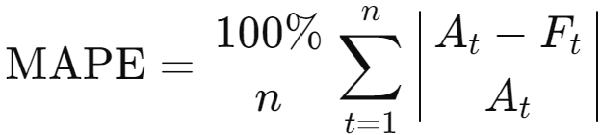
Equation 1: MAPE equation

MAE measures the average error magnitude in the same units as the data, offering straightforward accuracy assessment without considering error direction (Hodson, 2022).
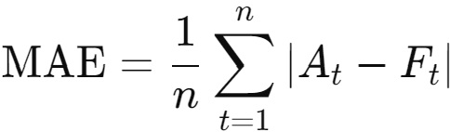
Equation 2: MAE equation

In constrast, despite not capturing the magnitude of those error, MPE accounts for error direction, indicating whether predictions systematically overestimate or underestimate actual values (Tayebi and Jin, 2015).
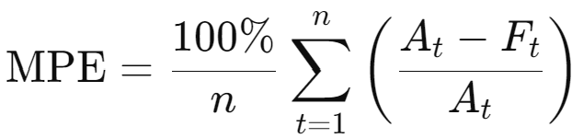
Equation 3: MPE equation

RMSE penalizes larger errors more heavily, making it sensitive to outliers and providing a measure of typical error size in the mode (Karunasingha, 2022).
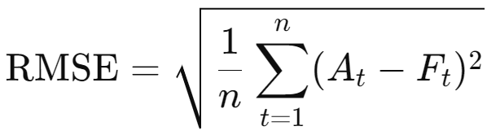
Equation 4: RMSE equation

Equation 5,6,7 and 8 define MAPE, MAE, MPE and RSME for 𝑛 observation, where 𝐴_{𝑡} represents the actual values and 𝐹_{𝑡} denotes the forecasted values at time t. Together, these metrics—MPE for directional bias, MAPE for scale-independent accuracy, MAE for average error magnitude, and RMSE for sensitivity to large errors— offer a comprehensive evaluation of a model’s performance, capturing both error magnitude and direction.
Chapter 4: Result Analysis
Chapter 4 provides a comprehensive assessment of UK and its regions housing sales forecasting. The univariate-and multivariate time series-models will be compared, to highlight their strengths and weaknesses. Additionally, the study explores hierarchical-forecasting methods, incorporating regional search subcategories and terms to improve forecast-accuracy and detail. These findings-contribute valuable insights for stakeholders in the housing industry.

4.1. Univariate time series forecasting—SARIMA
This section has two sub-sections, following the Box-Jenkins methodology-in Section 3.3.2, and explains-the input, process, and output of aggregate and hierarchical-forecasting using SARIMA.

    - Model identifications and parameters estimation
As outlined in Section 3.4.1, pre-Covid data was-extracted for consideration. Based on Table 6, Guerrero values of all time series are much less than 1, suggesting that their variance are not stable and applying a log transformation can significant reduce the variance compared to the original series. Moreover, despite passing the KPSS-test, the ADF-test determined that the housing-sales data for the UK and all its regions is non-stationary, as all p-values are greater than 0.05, demonstrated that we fail to reject the null hypothesis that these series have a unit root. Consequently, log transformation and-differencing are applied to all time series models for UK and its regions since SARIMA-model requires stationary-inputs and stable variance as summarise in Table 6. After achieving a stationary time series with homogeneity of variance, the ACF, PACF plots and ‘auto.arima’ function can be used to identify the appropriate SARIMA models.

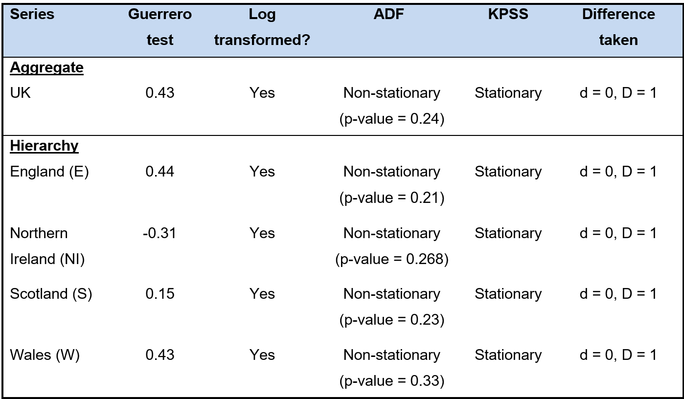
Table-6: Different-tests, transfromation-performed-and-difference-on-each-data-series (More detailed-in-Appendix 5) (“d” denote-non-seasonal-differencing-and “D” -denote-seasonal differencing)

    - Residual diagnostic and final model selection
Applying Box-Jenkin methodologies, this session-aims to assess the adequancy of candidate models through-various statistical tests. The final-model selection, as shown in Table 7, is based on the test conducted in Appendix 6.
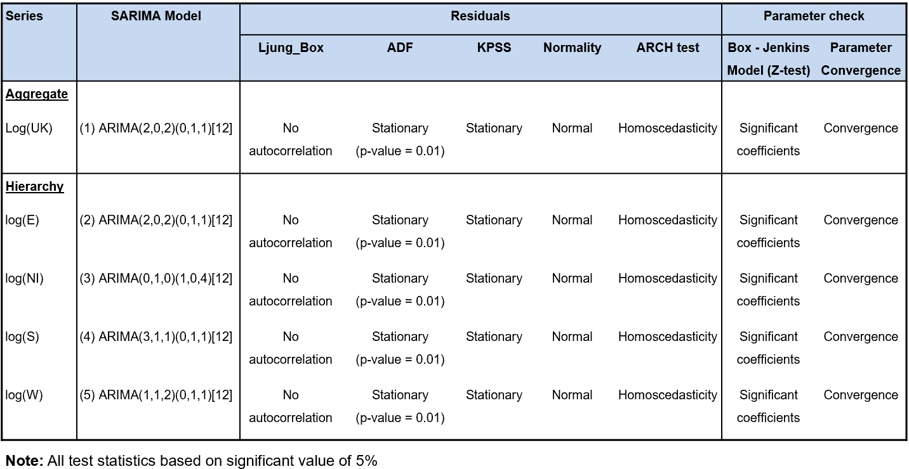
Table-7: The-final-SARIMA-model-selection-and-statistic-tests-for-each-series
D'Agostino (2017) emphasize that the goodness-of-fit of models can be assessed by analysing their residuals. Regarding a SARIMA model to be considered a good fit, its residuals should ideally exhibit stationary, normality, no significant autocorrelation and homoscedasticity (Dabral and Murry, 2017). Upon reviewing the models’ residuals, the model fit appears satisfactory across all series as shown in Table 7. Specifically, in Ljung-Box test, p-value of all time series are higher-than 0.05, suggesting that the-residuals are independently-distributed (no autocorrelation). Furthermore, when examining the ACF patterns, Figure 13 shows that all residuals are white noise, indicating that these models have generally captured the key dynamics of their respective time-series. Subsequently, the-residuals of all models exhibit low p-values (<0.05) in the ADF-test, and their test-statistics are below the critical-values in the KPSS test, confirming that these series are stationary. Based on histogram and QQ-plot, all residuals-are approximatly normally distributed, with only some minor deviations at the tails. Regarding ARCH test, we accept the null hypothesis in all cases as their p-value>0.05, demonstrating that the residual-variances are likely constant over-time.
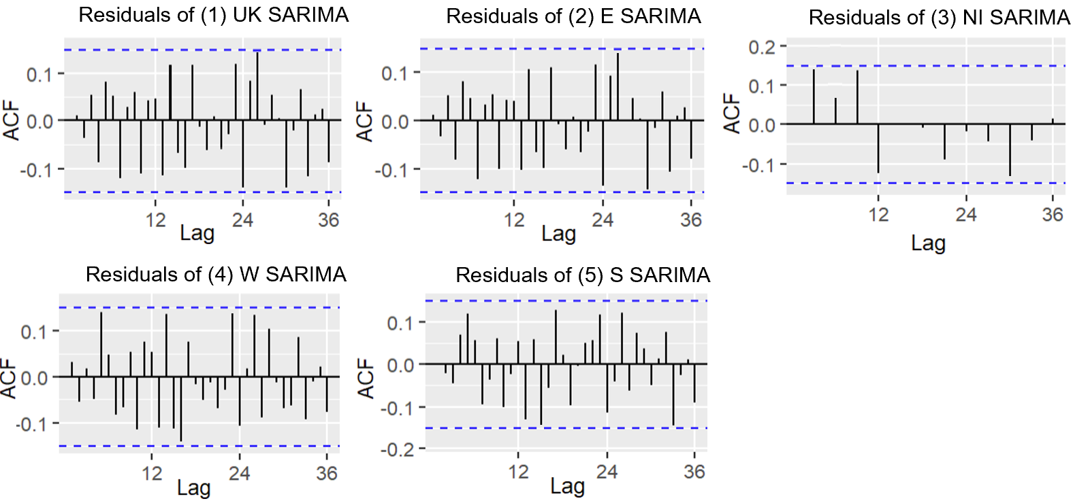
Figure-13: The-ACF-plot-of-residuals-of-final-SARIMA-model-of-UK-and-its-regions

By examining the-parameters at 5% significant level, all coefficients of all SARIMA-models are highly significant, indicating they are important components of the model. Besides, the constant Sum of Squared Errors (SSE) and parameter values across iterations indicate that SARIMA models of all series fitting process have successfully converged and the model parameters are stable. Overall, SARIMA models exhibited a good fit and maintained parsimony, with model parameters limited to the second order, effectively avoiding both underfitting-and-overfitting.

4.2. Multivariate time series forecasting—VECM

This sub-section will detail the inputs, processes and outputs involved in VECM models. Beyond the housing-sales volume, search-subcategories and SII (discussed in-Section 3.2) will be incorporated into the models to improve its predictive accuracy. Section 4.2.1 will focus on the key statistical tests necessary to determine the appropriate model parameters, while Section 4.2.2 will examine-the model’s goodness-of-fit and the final-selection of the-optimal model.

4.2.1. Determining lag and cointegration test

As outlined in Section 3.3.4, the VECM model extends VAR by integrating cointegration among the variables, indicating the presence of a long-term equilibrium relationship. For VECM to be-appropriate, there must be at least one cointegration-relationship among the time series variables being modelled. Hence, the Johansen cointegration test is applied to determine the cointegration rank and confirming the presence of a stable long-term equilibrium relationship-between the-variables.

Table 8 summarises the-cointegration test’s results between housing sales and search subcategories (or SII) for UK and-each regions. The findings-from the Johansen test clearly show that the time series variables exhibit a-single cointegrating relationship in all cases, except for England and Northern Ireland that using search subcategories with two cointegrating relationships. Particularly, the rejection of the null hypothesis $r=0$, indicated by test statistics exceeding the 5% critical values, confirms the presence of a cointegrating relationship. Conversely, the failure to reject $r≤1$ suggests that the data does not support the existence of more than one cointegrating vector. In two expectional cases, the rejection of $r=0$ and $r≤1,$ and the non-rejection of $r≤2$ indicates that their variables share two long-term equilibrium relationships. Remarkably, for England, even though the tests reject both $r=0$ and $r≤1,$ there remains one cointegrating relationship between England housing sales and England SII.

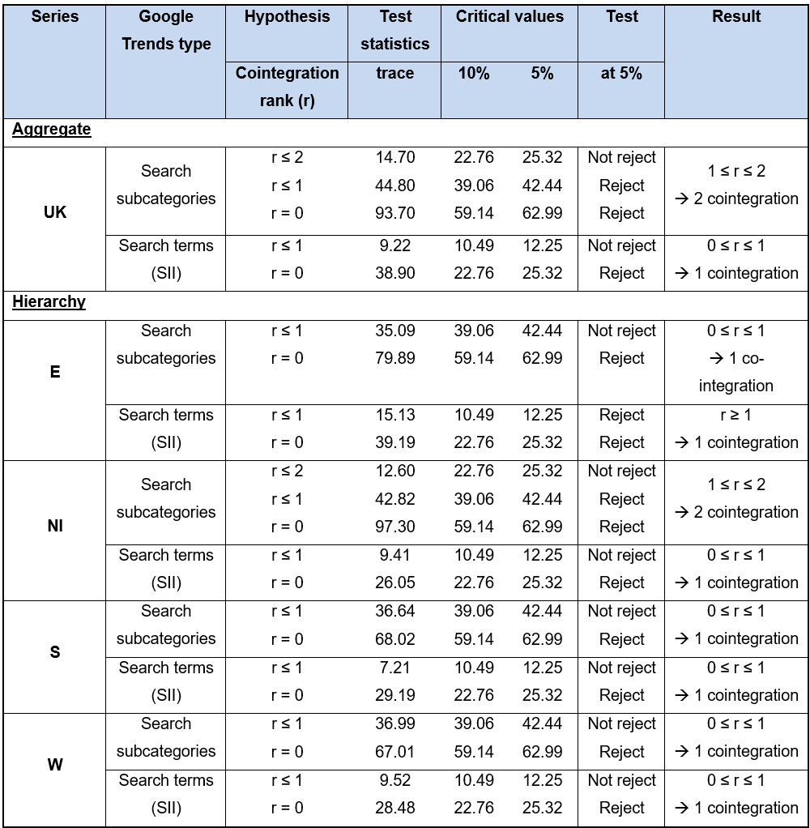
Table-8: Johansen’s-cointegration-test-result-between-housing-sales-and-search subcategories- (or-SII) -for-UK-and-each-regions

4.2.2. Diagnostic and final model selection
All series have been fitted using VECM with the specified cointegration rank and corresponding lag order as indicated in Table 9. A thorough examination of the residuals indicates that they exhibit no autocorrelation nor significant deviations from normality, as confirmed by the Ljung-Box test, histogram and QQ-plot (Appendix 10). Moreover, the ADF and KPSS tests indicate that all residuals exhibit stationarity. However, the homoscedasticity results are inconclusive, as ARCH test demonstrate heteroscedasticity for England, Northern Ireland and Wales of VECM models (model 9,11,15) that using SII inputs. Still, the visual inspection of the 'Residuals vs. Fitted Values' plots in Appendix 9 indicates that these models fit the data reasonably well, with no obvious patterns detected in the residuals, despite the presence of minor outliers. The observed outliers could be attributed to a misalignment in the cut-off points between the training sets of housing sales and SII series, possibly causing errors in the subsequent observations. Overall, while the models may not satisfy all statistical criterion, they effectively capture the underlying processes, as supported by the visual representations.

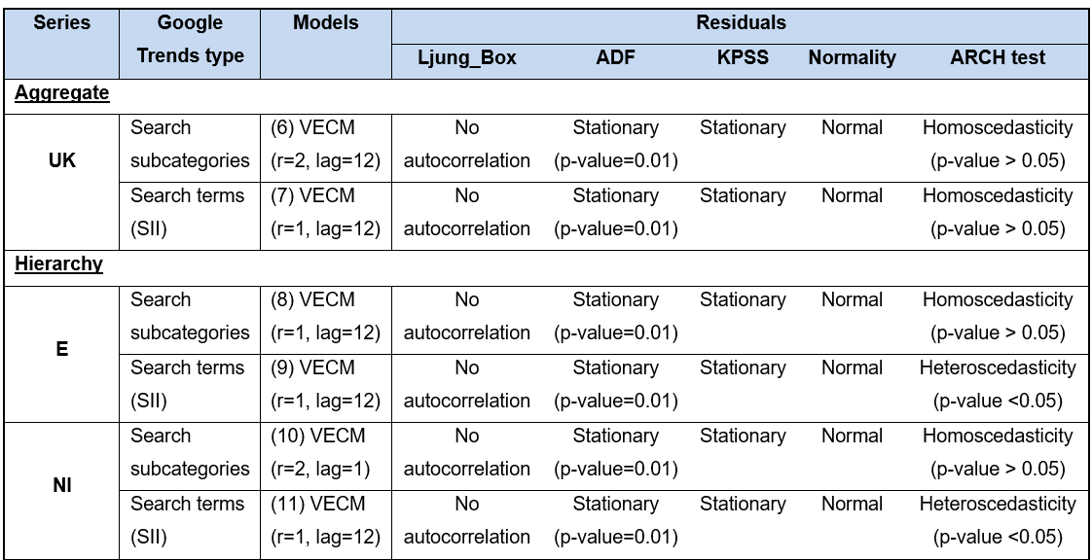
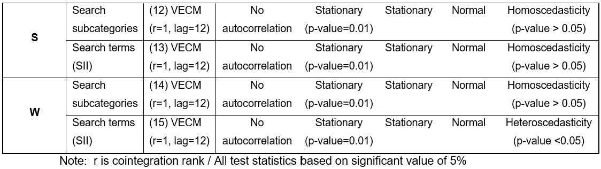
Table-9: Final-VECM-model-selection-for-each-series

4.3. Forecasting evaluation between Univariate and Multivariate models
As mentioned in Section-3.4.1, we split the dataset into training data (in-sample) from January 2005 to February 2019, and-a test-set (out-of-sample) from March 2019 to February 2020, to evaluate the performance of the-forecasting models. This-session-is divided into two main parts. First, we will compare-the results from ARIMA-and-VECM in their ability to forecast housing sales for UK and each region-individually. Second, as mentioned in Section 3.3.5, four region-based forecasts will be integrated to create hierarchical models using ARIMA(H) and VECM(H) to forecast the whole UK housing sales, enabling a comparison between aggregate and hierarchical inputs. Specifically, each corresponding model will be created from the 'Aggregate' (A) input, which includes model (1) for SARIMA(A) and models (6) and (7) for VECM(A), while the remaining models are used for 'Hierarchical' (H) input. Accordingly, based on the different inputs, six overall models will be compared in terms of forecasting performance for UK housing transaction volume. These include SARIMA(A), SARIMA(H), VECM(A)—SSC (search subcategories), VECM(A)—SII, VECM(H)—SSC (search subcategories), and VECM(H)—SII. Prominently, the predicted values in the SARIMA model will be transformed back to the original scale using the exponential function from the logarithmic model. The results of the individual models are provided in Appendix 7 and 11.

Regrading evaluation metrics, according to the framework of Takami et al. (2020) regarding MAPE, forecasts with errors under 10% are classified as "highly accurate," those between 10% and 20% as "good," errors from 20% to 50% as "reasonable," and errors over 50% as "inaccurate". Additionally, an MPE close to zero indicates minimal bias, with forecasts well-balanced between overestimation and underestimation, while a significantly negative or positive MPE reflects a consistent tendency to underestimate or overestimate, respectively (Karakoti et al., 2011). Lastly, for both MAE and RMSE, smaller values indicate better model performance (Chai and Draxler, 2014).

4.3.1. UK and Regional Forecast Comparison
This sub-section will examine three models’ performances, including SARIMA, VECM with search subcategories (VECM-SSC) and VECM with SII (VECM-SII) for UK and its regions based on key metrics MAPE, MAE, MPE and RMSE.

4.3.1.1. UK series
From table 10, the VECM-SII model outperforms the other two, as evidenced by its lowest MAPE (3.06%), MAE (2456.45), and RMSE (2738.39), indicating that it provides the most accurate forecasts with the smallest errors. Moreover, ARIMA model performs moderately well, with a MAPE of 3.75% and an RMSE of 3595.33, but it is less precise than the VECM-SII. The VECM-SSC model, however, shows the weakest performance, with the highest MAPE (5.03%) and RMSE (4940.08), suggesting that it is less effective at capturing the actual sales trends.

In terms of forecast bias, the SARIMA model shows a slight underestimation with an negative MPE of -0.18%, and VECM-SII model also slightly underestimates at MPE of -0.19%, both with minimal bias. Conversely, VECM-SSC model significantly overestimates housing sales volume, with a positive MPE of 4.83%, indicating a tendency to predict higher values than observed.
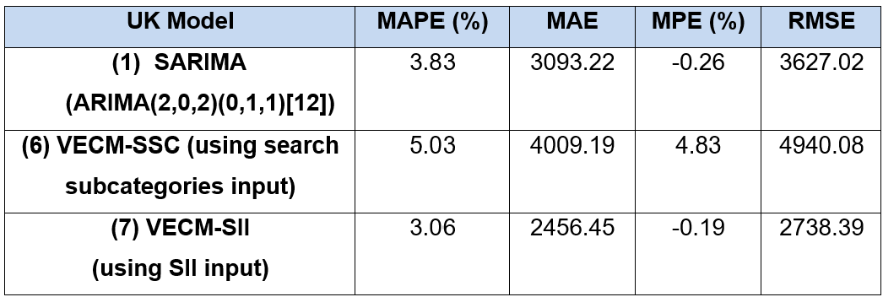
Table 10: The evaluation metrics of all UK series models
Figure 14 confirms that VECM-SII model closely follows the actual UK sales volume throughout the forecast period, with SARIMA model showing slightly more deviation. In contrast, VECM-SSC model diverges significantly, especially during high sales periods, reflecting its overestimation bias. Overall, the VECM-SII model is the most accurate, followed by ARIMA, with VECM-SSC being the least accurate due to its overestimation.

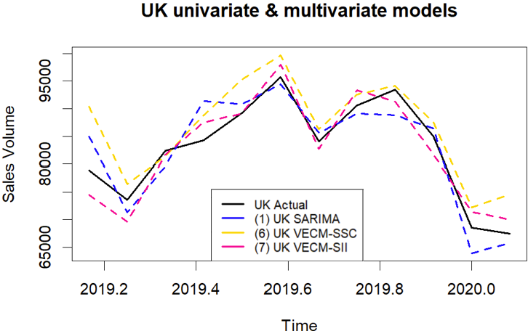
Figure 14: Comparison among three models in forecasting UK housing sales test dataset

4.3.1.2. England series
Regarding England, VECM-SII model demonstrates superior accuracy, achieving the lowest MAPE (3.41%) and MAE (2227.69), as well as the lowest RMSE (2820.97), indicating it provides the most precise predictions (Table 11). Additionally, despite slightly underestimating, the model has the smallest bias in its predictions, with an negative MPE of -0.53%. Conversely, VECM-SSC model shows slightly better performance than SARIMA model in terms of MAPE and MAE, with values of 3.52% and 2319.19, respectively, compared to SARIMA’s 3.55% and 2365.06. However, SARIMA performs slightly better on MPE and RMSE, indicating less bias in overestimation. Thus, VECM-SSC is slightly better overall for forecasting, but SARIMA could be preferable if minimizing large errors.

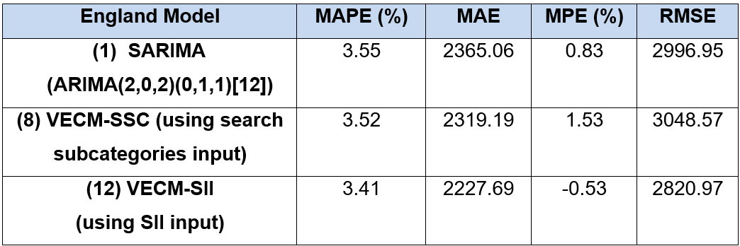
Table 11: The evaluation metrics of all England series models

Besides, while SARIMA and VECM-SSC exhibit greater deviations, particularly during periods of significant sales increases, VECM-SII model closely mirrors England’s actual sales volume (Figure 15). Overall, VECM-SII emerges as the most reliable model for predicting England's housing sales, followed by VECM-SSC, with SARIMA being the least accurate.

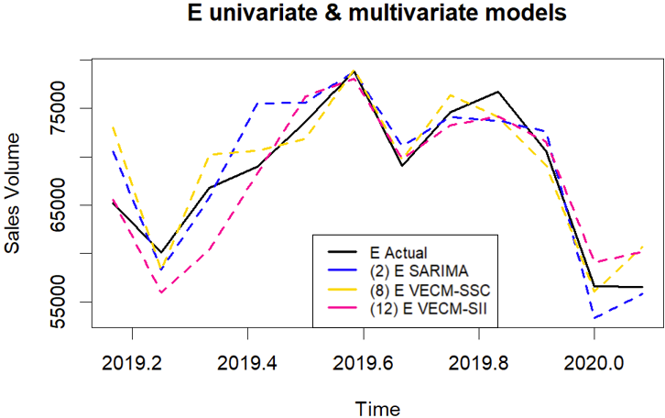
Figure 15: Comparison among three models in forecasting England’s housing sales test dataset

4.3.1.3. Northern Ireland series
Similarly, among these, VECM-SII model stands out with the lowest MAPE (9.1%) and MAE (198.58), indicating superior accuracy in predicting Northern Ireland’s housing sales volumes (Table 12). Additionally, exhibits the smallest bias with an MPE of -8.6%, suggesting a more balanced prediction performance. This is further supported by its lowest RMSE of 230.21, indicating fewer and smaller errors compared to the other models. Differently, SARIMA model, with the highest MAPE (12.27%) and MAE (266.02), emerges as the least accurate, consistently underestimating sales volumes, as reflected in its substantial negative MPE of -12.27%.

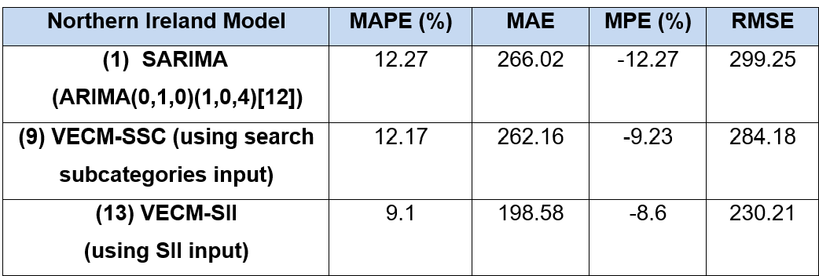
Table 12: The evaluation metrics of all Northern Ireland series models
Figure 16 reinforces these findings, showing that the VECM-SII model moderately tracks the actual sales data, whereas the SARIMA and VECM-SSC models exhibit larger deviations, especially during periods of sharp fluctuations. Although the VECM-SII model is considered the most reliable, all three models struggled to accurately capture the changes in Northern Ireland's housing market during the Brexit period. The unique geographic location, coupled with significant economic and political challenges, likely heightened uncertainty and caused unpredictable market fluctuations, making it difficult for the models to fully capture the unprecedented and rapidly changing conditions, resulting in less accurate forecasts.

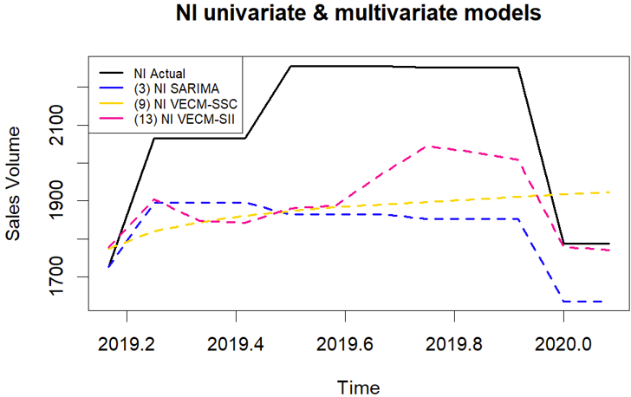
Figure-16: Comparison-among-three-models-in-forecasting-Northern-Ireland’s-housing-sales test dataset

4.3.1.4. Scotland series
Based on Table 13, VECM-SII model still emerges as the most effective, with the lowest MAPE (3.86%) and MAE (346.45), indicating its superior ability to predict Scotland's housing sales. This model also achieves the lowest RMSE (472.40), further underscoring its accuracy in forecasting. Besides, SARIMA model, with a MAPE of 5.88% and an RMSE of 634.91, performs reasonably well but shows a higher tendency to underestimate sales, as reflected in its MPE of -4.38%. VECM-SSC, on the other hand, records the highest errors, with a MAPE of 6.92% and an RMSE of 709.89, making it the least reliable model in this context.
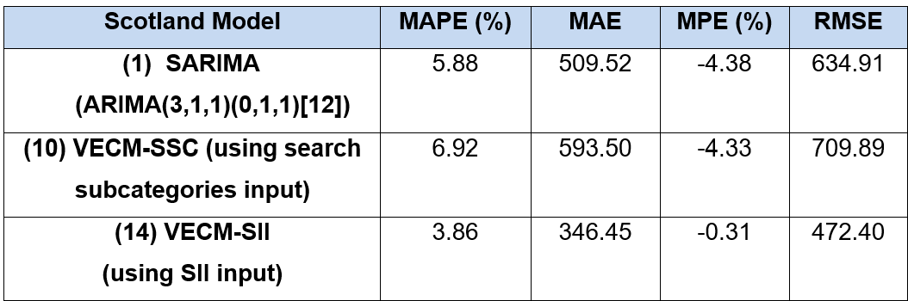
Table-13: The-evaluation-metrics-of-all-Scotland-series-models

Graphically, Scotland’s actual sales data aligns most closely with the VECM-SII model, while SARIMA and VECM-SSC show more significant deviations, particularly during periods of higher sales (Figure 17). Collectively, VECM-SII is the most accurate and reliable model for predicting Scotland's housing sales, followed by SARIMA, with VECM-SSC showing the least accuracy due to its higher error rates.

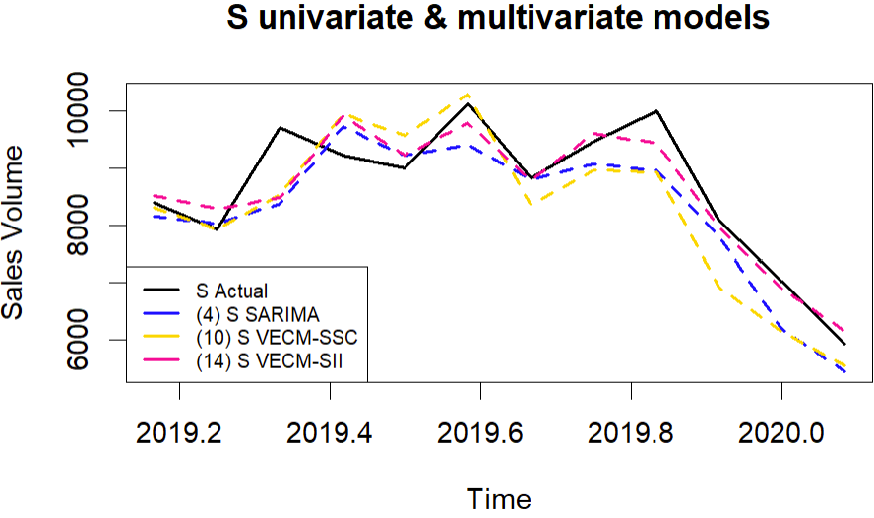
Figure-17: -Comparison-among-three-models-in forecasting-Scotland’s-housing-sales-test dataset

4.3.1.5. Wales series
The VECM-SSC model exhibits the highest error rates among the three models, with a MAPE of 8.74%, MAE of 8.63%, and an RMSE of 416.55 (Table 14). Additionally, it tends to underestimate sales, as indicated by its negative MPE of -5.15%. Following this, the SARIMA model demonstrates slightly better accuracy, with a MAPE of 6.72%, MAE of 264.83, and an RMSE of 316.76. However, it also slightly overestimates sales volumes, as suggested by its positive MPE of 6.41%. In contrast, the VECM-SII model emerges as the most accurate, with the lowest MAPE of 4.03%, MAE of 145.41, and RMSE of 214.49, indicating fewer and smaller prediction errors. Although it shows a slight overestimation in sales volumes with a moderate MPE of 3.21%, this remains within an acceptable range.
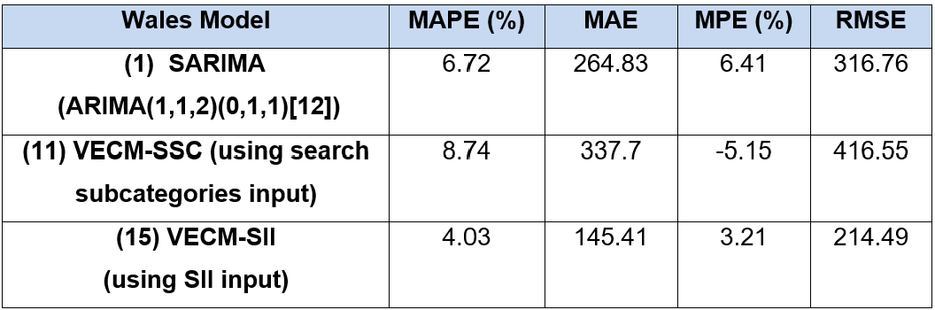
Table-14: The-evaluation-metrics-of-all-Wales-series-models

Figure 18 shows that whereas SARIMA and VECM-SSC model deviate more from the actual sales, VECM-SII is the most closely aligned, consistent with the above metrics. This underscores the VECM-SII model as the most dependable forecasting tool for Wales, while SARIMA and VECM-SSC deliver less accurate predictions.

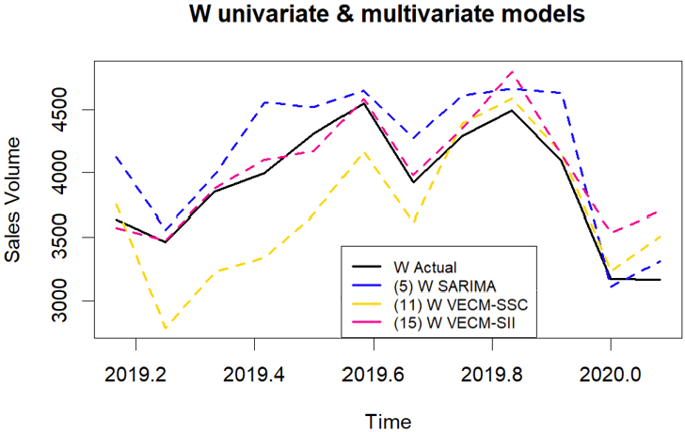
Figure-18: Comparison-among-three-models-in-forecasting-Wales’s-housing-sales-test dataset

In general, all models performed exceptionally well across regions, with MAPE values below 10%, placing them in the 'highly accurate' category, except-for Northern-Ireland’s SARIMA and VECM-SSC, which fall into the 'good' category. Among them, VECM-SII models consistently outperform with approximately 96% accuracy across-all regions, except for Northern-Ireland at 91%, making it-the best overall model-for forecasting housing sales with the lowest error metrics. In contrast, SARIMA-exhibits the-worst performance in England and Northern Ireland case, meanwhile VECM-SSC models demonstrates the poorest performance in UK and Scotland and Wales, where they record the highest error metrics.

4.3.2. Aggregate and Hierarchical Forecast Evaluation
As previously stated, this section will evaluate the 'Aggregate' and 'Hierarchical' models in their ability-to predict UK housing sales. Figure 19 illustrates the comparison between UK actual sales volumes and the-forecasts generated by different models, highlighting three notable features. First, all six models successfully-captured the fluctuations in actual housing sales over the 12-month forecast period, particularly the notable peaks and troughs around mid-2019 and early 2020. This aligns with expectations, as these models specifically include terms designed to capture seasonal factors. However, there is a noticeable deviation in March 2019 and February 2020 across most models, suggesting that they largely failed to account for the fluctuations in the UK housing market following the ‘Brexit Deal Rejections’ and the onset of the Covid-19 pandemic. Finally, both VECM-SII models outperformed the others, though the difference was minimal.
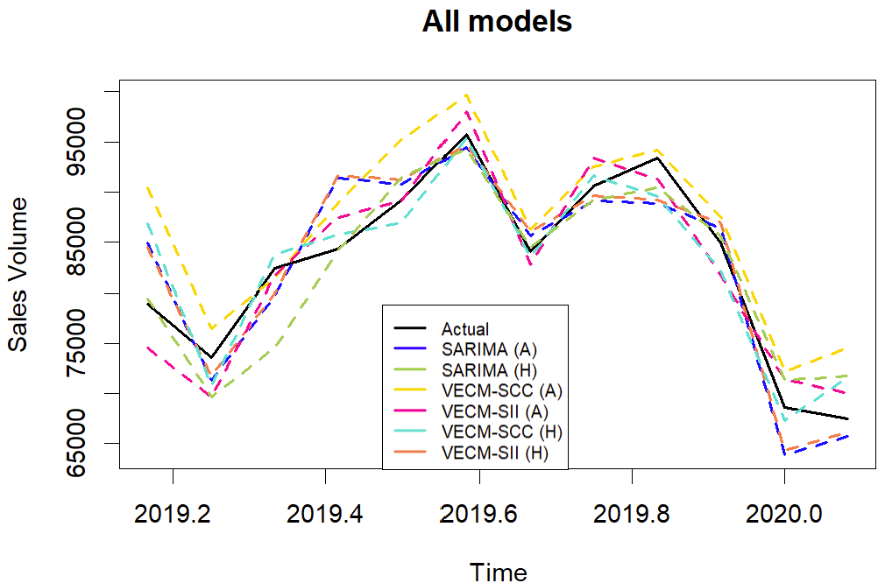
Figure-19: -The-graph-of-forecasts-of-each-model-vs. -actual-UK-housing-sales

Besides, Tables 15 and 16 offer a comprehensive overview of monthly forecast performance, evaluated metrics, and bias for each model. By analysing MAPE values, all models fall within the "highly accurate" range, each with a MAPE below 10%. However, it reveals that the SARIMA, VECM-SSC, and VECM-SII models exhibit varying levels of accuracy, with the 'Hierarchical' approach being better than the 'Aggregate' technique in all cases. Among models, VECM-SII, both Aggregate and Hierarchical, deliver the best performance among the evaluated models. In which, VECM-SII(H) achieves the lowest values at all metrics of errors, demonstrating the highest accuracy of over 97% (as MAPE of 2.66%), while VECM-SII(A) also perform well with MAPE (3.06%), MAE(2456.45) and RMSE (2738.39). Both models have a very slight under-prediction bias. The SARIMA models perform relatively robust overall, with SARIMA(H) slightly outperforming SARIMA(A) by achieving a lower MAPE (3.58% vs. 3.83%), MAE (2915 vs. 3093) and RSME (3494 vs. 3627). Additionally, SARIMA(H) has a slightly positive MPE (0.22%), indicating a small tendency to overestimate, whereas SARIMA(A) has slightly underestimates, with negative MPE (-0.26%). In contrast, VECM-SSC(A) model exhibits the weakest performance, marked by the highest MAPE (5.04%), MAE (4009.19), and RMSE (4940.08) with a notably positive MPE (4.85%), indicating a consistent overestimation bias. However, the hierarchical counterpart, VECM-SSC(H), performs significantly better and ranks among the top three most accurate prediction models.
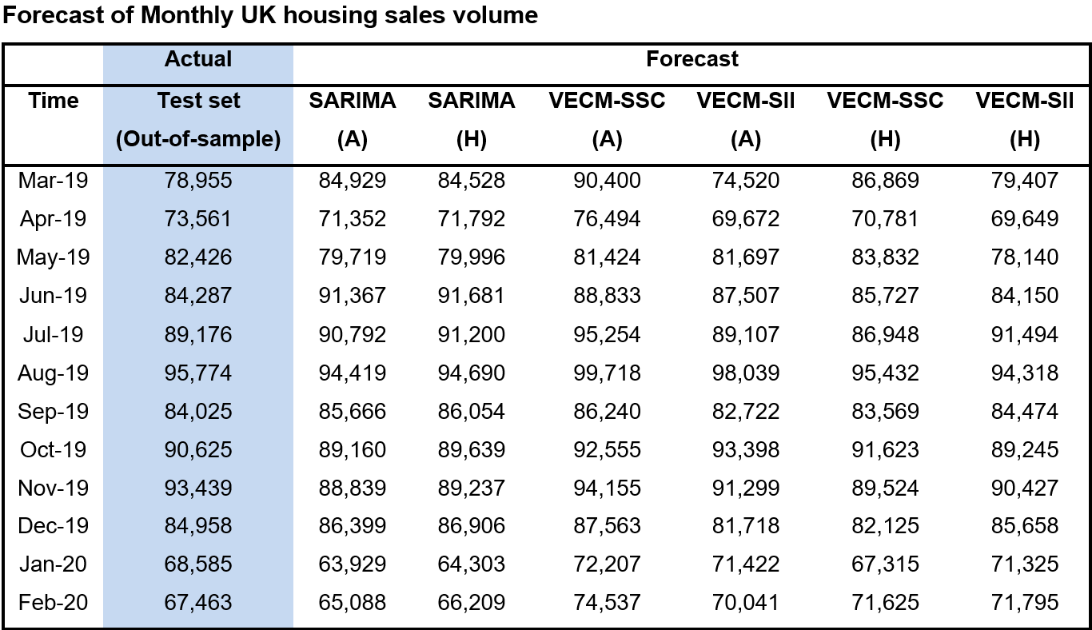
Table-15: Comparison-of-12-month-forecast-point-estimates
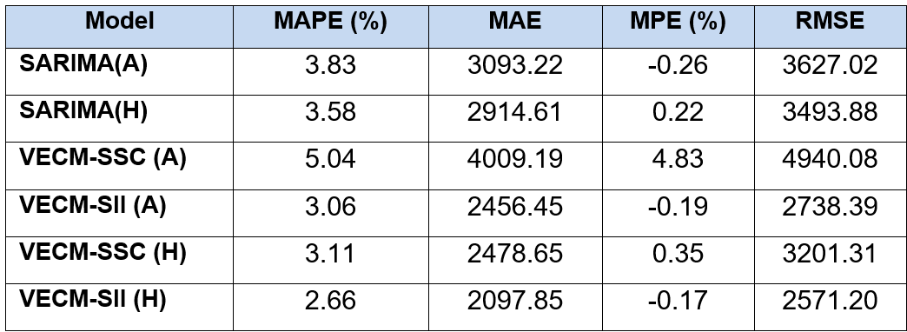
Table-16: -The-evaluation-metrics-of-all-models

However, certain months, particularly March 2019 and February 2020, pose significant challenges for most models. In March 2019, SARIMA models ('Hierarchical' and 'Aggregate') show relatively high MAPE values of 7.57% and 7.06%, respectively, while VECM-SSC(A) model records an exceptionally high MAPE of 14.50% (Figure 20). The MPE values during this month also reveal substantial biases, especially for the VECM-SSC(A) model, suggesting a tendency toward significant overestimation. Similarly, February 2020 presents challenges, with VECM-SSC(A) model again showing a high MAPE of 10.49% and significant bias. Additionally, VECM-SSC(H) and VECM-SII(H) models exhibit moderately high MAPE values, further indicating considerable forecast errors and biases in this month. These observations align with the findings in Figure 19, which suggest that these models struggled to capture the unusual fluctuations during these two months.

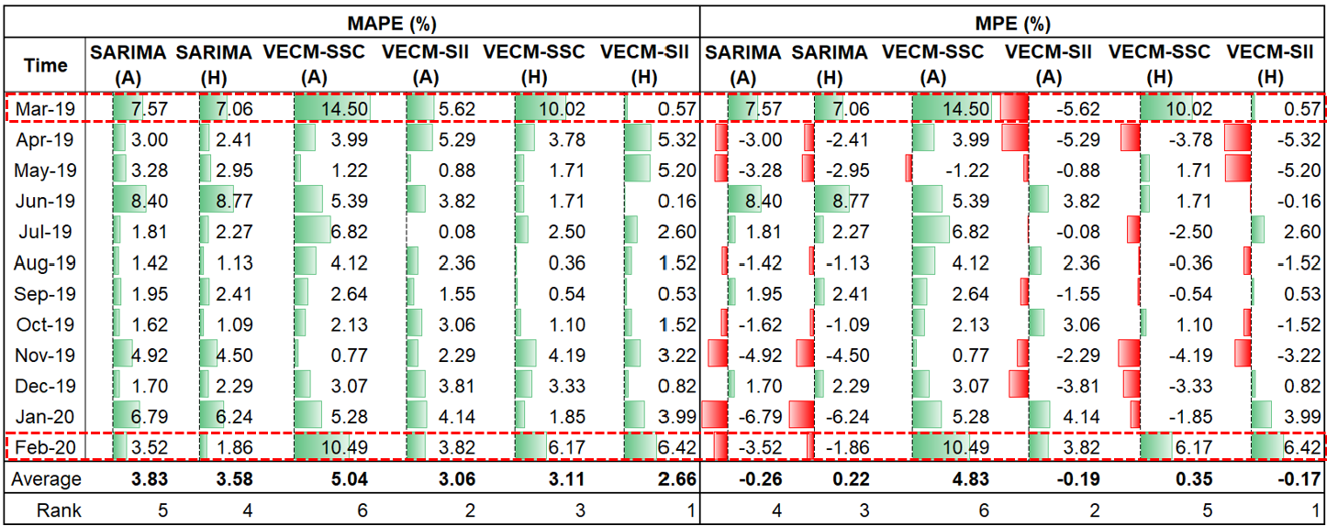
Figure-20: -Comaprision-of-forecast-error-of-monthly-UK-housing-sales

Overall, VECM-SII outperforms SARIMA and VECM-SSC in regional comparisons and ‘Aggregate’ vs. ‘Hierarchical’ model comparisons. In all cases, Hierarchical models outperform Aggregate models and VECM-SII models demonstrate the best predictive performance. Remarkably, except for the worst model, VECM-SSC(A), all models have MAPE and MPE differences of less than 1.5%, indicating high prediction accuracy. These findings have important caveats that will be discussed in the next chapter.

Chapter 5: Discussion and Conclusion
The final chapter will relate the findings to the three research questions, compare them with existing literature, and discuss the study's limitations and future research directions.

5.1. Discussion of the results
This study has successfully achieved its objectives by addressing all the research questions in Table 17.
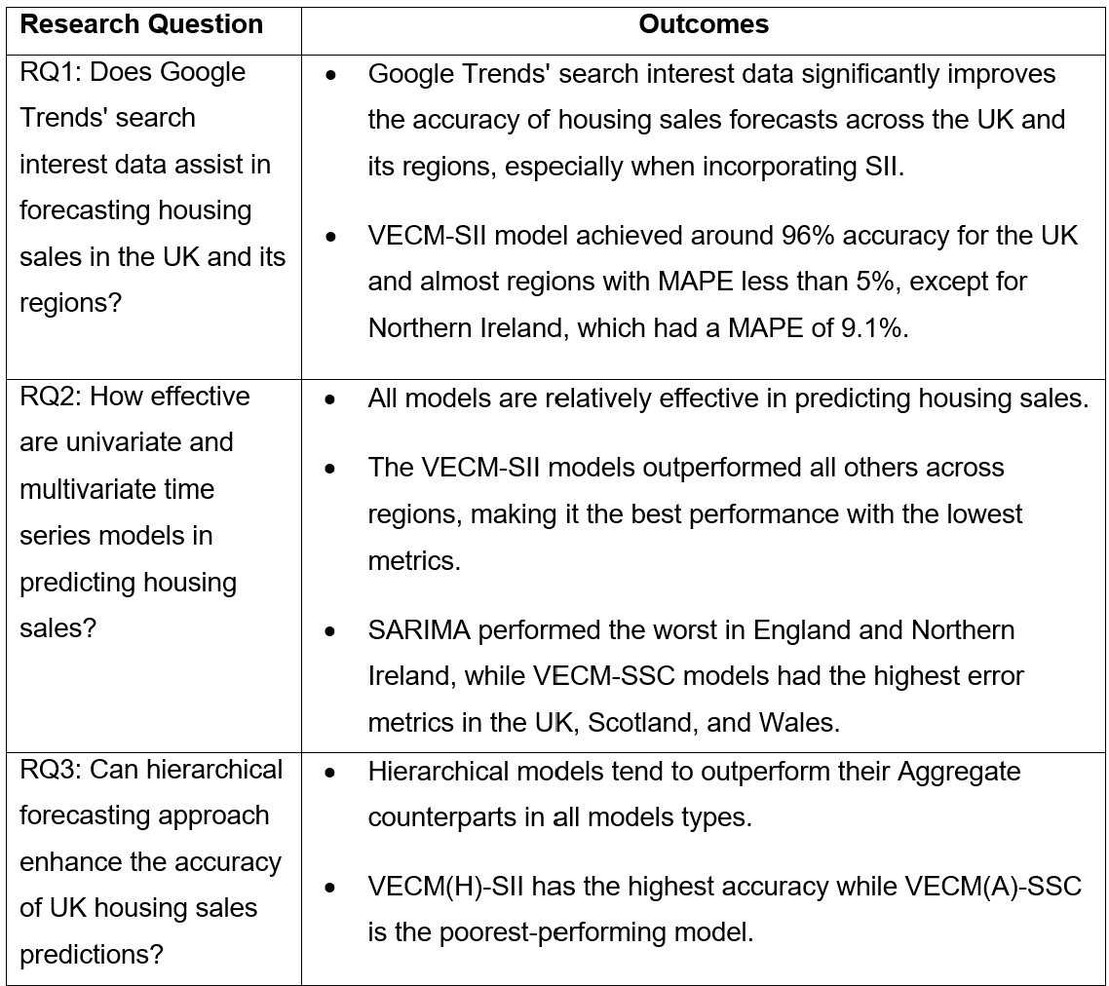
Table-17: Summary-of-research-questions-and-outcomes

Firstly, this study-demonstrates that incorporating Google Trends’ search-interest data enhances the ability to forecast housing sales in the UK and its regions, answering RQ1. Specifically, a straightforward-framework for developing SII proved to be a reliable-predictor of housing sales despite its-simplicity. By integrating Google-Trends’ SII data, the VECM-SII model achieved the highest-accuracy—up to 91% for Northern Ireland and more than 96% for the UK and other regions, with all MAPE errors under 10%. However, Google Trends’ subcategories performed worse, achieving only 95% accuracy for the UK and England, and around 90-93% for Scotland and-Wales, with 88% accuracy for Northern-Ireland, but it is still classified as ‘good’ model. Nevertheless, the results from both cases even surpass the findings of Humphrey (2010) and-Belej (2023). This improvement may may-be attributed to differences in housing markets-across countries and better-optimization of search-terms and subcategories tailored to the UK market.

Secondly, by comparing the SARIMA-and VECM-models from both theoretical and-practical perspectives, this research addresses RQ2. Despite lacking MA terms, the VECM model outperforms SARIMA, especially when enhanced with the SII. In fact, VECM-SSC also shows higher accuracy than SARIMA in forecasting housing-sales in England and Northern-Ireland. This supports Stevenson’s (2007) view that multivariate approaches improve forecasting accuracy, as seen in Bangladesh’s housing market. Furthermore, VECM’s superiority can stem from its ability-to incorporate relevant variables like Google-Trends data, capture market dynamics, handle non-stationary data, and account for long-term relationships, making it more accurate and responsive to market-conditions, aligning with Varli-and Erdem’s (2014) findings.

However, the SARIMA model still demonstrates relatively high forecasting effectiveness, trailing the VECM-SII-by less than 1.5% and outperforming VECM-SSC for the-UK, Scotland, and Wales. Aside from Northern-Ireland, where accuracy is around 87.7%, SARIMA achieves 93-95% accuracy in all other cases. This is consistent with Vishwakarma (2013) and Abuanzeh (2023) research, demonstrating that simpler models-like SARIMA remain-valuable in certain scenarios. This insight contributes to the ongoing debate about balancing model complexity-with-practical-applicability.

Lastly, this study introduces an innovative hierarchical approach for forecasting housing sales, addressing RQ3. This-method improves model-accuracy, with the best-model, VECM-SII(H), achieving over 97% accuracy. Moreover, the hierarchical approach allows for precise adjustments to each series' unique characteristics, enhancing the capture of localized trends, sensitivity to regional-shocks, and better management of-seasonality and cyclicality, thereby boosting forecast-reliability. Paricularly, specific-model parameterization is applied to each regional-series-to-effectively capture its unique patterns.

5.2. Implication and recommendation to UK’s housing sector
This study offers actionable insights for the UK's housing sector, with three key recommendations.
Firstly, our-analysis identifies seasonal demand-variations—higher in summer, lower in winter—with distinct regional buyer behaviour. These insights enable-real estate developers, estate agents, and-organizations like-the National-House-Building-Council to tailor marketing and pricing strategies to different buyer segments-during various market-phases, promoting balanced sales, market-stability, and steady revenue streams.

Secondly, our exploration of Google-Trends data, including search categories and SII, confirms long-term cointegration with housing sales. This-suggests that policymakers and industry stakeholders-should incorporate such data into forecasting models for improved accuracy and timeliness. Additionally, this research proposes a framework for developing SII that integrates seamlessly with VECM-models, offering a robust alternative to SARIMA. This multivariate-approach offers real-time data and supports automation, as-VECM, unlike ARIMA, does not require continual re-parameterization to maintain its effectiveness.

Lastly, while-hierarchical forecasting offers detailed regional-insights, further-research is needed to refine this approach and reduce errors. Given the-dynamic housing market, continuous-monitoring and regular updates to forecasting models are essential to ensure ongoing relevance-and accuracy.

5.3. Limitation
This research-has several limitations. First, data constraints, with housing-data available only from 2005 onwards, hinder-capturing long-term trends and analysing earlier market-events, limiting the comprehensiveness of the findings. Future-studies could benefit from extended datasets for better long-term insights. Second, although-useful, Google-Trends search interest data reflects behaviours that may not directly translate into actual market outcomes and may fail to fully capture the factors influencing the housing market. Third, the study-focuses on English-terms and web searches, potentially overlooking regional languages like Welsh or Scottish Gaelic and other search types (e.g., image, video, news) that could also be valuable predictors. The shift-and-sum method, though simple, lacks-robustness as it applies equal weighting to all search terms without considering their varying correlations with housing sales. Lastly, the study evaluates only one model from each methodology (SARIMA-and-VECM), limiting the-generalizability of the-findings in determining whether-multivariate models with Google Trends datat, especially SII, truly-outperform univariate-models.

5.4. Conclusion and Future research
In conclusion, this study-successfully explored three research questions. The findings-confirm that integrating search-interest data improves forecast-accuracy, particularly incorporating SII into VECM model. Moreover, multivariate models generally outperformed univariate ones. The hierarchical-approach has improved prediction accuracy by providing-valuable region-specific insights, contributing a new-finding to the literature and forecasting-methodology of housing sales. Overall, the-research achieved its objectives and addressed all research-questions, offering practical-implications for policymakers and industry-stakeholders.

However, there are various avenues for further research to address limitations and enhance enhance the robustness and applicability of these-findings. Firstly, future research should use longer timeframe and incorporate additional economic and geographical data, such as unemployment rates, interest rate, income levels, and regional indicators, into forecasting models to enhance model accuracy and generalizability, particularly in analysing regional differences across the-UK. Secondly due to the limitations of the shift-and-sum method, future research could apply-PCA to develop the SII as an input for forecasting time-series models and compare the effectiveness of both approaches. Thirdly, while this study focuses on VECM as a multivariate-model, advances in AI and Machine-Learning, particularly ANNs, may better capture sudden market-shifts, as noted in the literature-review, especially since both SARIMA and VECM struggled to predict March-2019 and December-2020 accurately. Xu and Zhang (2021) reviewed positive outcomes using ANNs for predicting housing sales by capturing non-linear relationships that traditional-models might neglect. Future-research could explore this comparison further, incorporating a hierarchical approach to assess the effectiveness of transforming statistical models into ANNs. Additionally, a new aspect to explore could be adding more-granularity by focusing on sub-regional and local-level within the-UK, offering deeper micro-level insights. This could include a wider range of search-terms, regional dialects, and different types of search-traffic. Lastly, while this study is centred on the-UK, these-methodologies could be applied to other-countries or regions, allowing for a broader comparison of housing-market dynamics-globally.

